**Reflective Learning Journal Template – BRG28-ISEA**

**Student Name: Chai Wei Zhe**  
**Student ID: CT0388103, 35900251**  
**GitHub Repository Link:** [**https://github.com/CWZ123HHS/BRG_ISEA/blob/main/README.md**](https://github.com/CWZ123HHS/BRG_ISEA/blob/main/README.md)**Video Walkthrough Link:**

### 1. Introduction

This reflection journal is about my learning experience in the course "Introduction to Server Environments and Architectures". Throughout the 4 lessons of this course, I was introduced to the foundational concepts in relation to the server infrastructure, deployment models, and the role of servers in supporting web and network-based applications. After going through the 4 days of lessons and lab activities, I have gained practical insights and deeper understanding of how server environments operate in real-world scenarios. This reflection journal will highlight the lab activities that I have done, challenges faced, and knowledge learnt.

### 2. Linux Environment Setup and GitHub Integration

During the setup of the Linux environment, we were told to either use virtualisation software like VirtualBox or VMware Workstation Pro to set up the Ubuntu image. However, the VM could not run properly when I was using the VirtualBox. After completing the default setup, I am able to log in to the installation page. Once the settings are configured and installation starts, I then encounter a problem. The installation of Ubuntu starts to lag, then the progress status stops and stays there. The first half of the lesson was just trying to resolve this issue. Then before lunch, I changed to using VMware Workstation Pro instead. The whole process was smooth, Ubuntu managed to be installed, and I can continue with the lab activities.

I have learnt that Virtualisation tools is a type of software that simulates a virtualised environment to run an operating system on a machine-like servers or computers. It can allow things like running Ubuntu Linux in the Windows environment. The environment configured is based on the performance of the physical system, meaning that the maximum output of the environment will not exceed the physical system as they are sharing the same storage.

For example, the disk size that I am using has a maximum storage of 520GB, there are some other system data and program data that use up 30GB. The maximum available size for the current virtual machine will not exceed 490GB unless I upgrade the disk size to a larger one, like installing a larger solid-state drive (SSD).

There are a few types of virtualisation tools, such as VMware Workstation and VirtualBox:

* VMware Workstation provides advanced features, high performance, mainly supports Windows and Linux.
* VirtualBox, free and open source, supports Windows, Linux, macOS, Solaris.

After completing this lab, I would say that although I have gotten some hands-on experience in using Ubuntu, my level of understanding and skills are still not up to the standard of where I can say I am confident to using it. I will require more practice and studying in this field to be more familiarised with it.

**Lab 1a-1 Virtualisation and Linux Setup:**

First, I have installed VMware Workstation Pro.

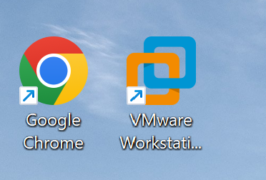

Next, I downloaded this disc image: ubuntu-24.04.3-desktop-amd64.iso

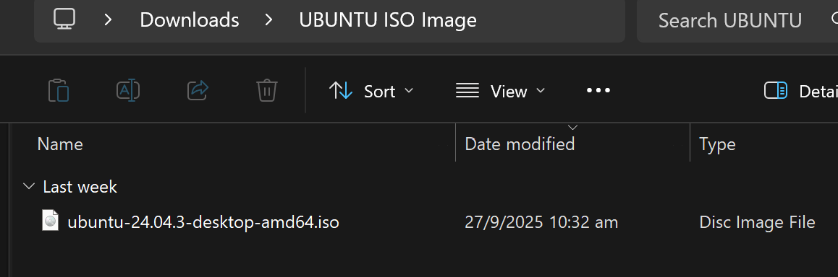

For the setup, use the image downloaded for ubuntu installation, then follow by the name of the VM, size of 20GB, memory is set as default of 4096MB, network default setting remains as NAT. Then click the finish button, the VM will start to set up.

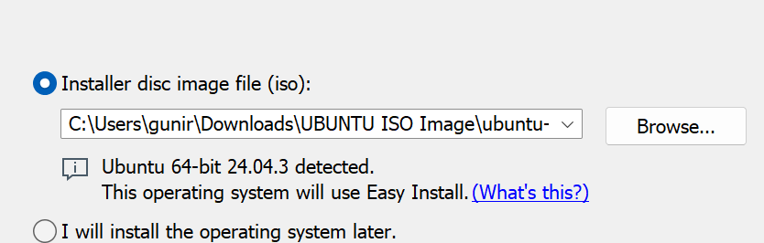

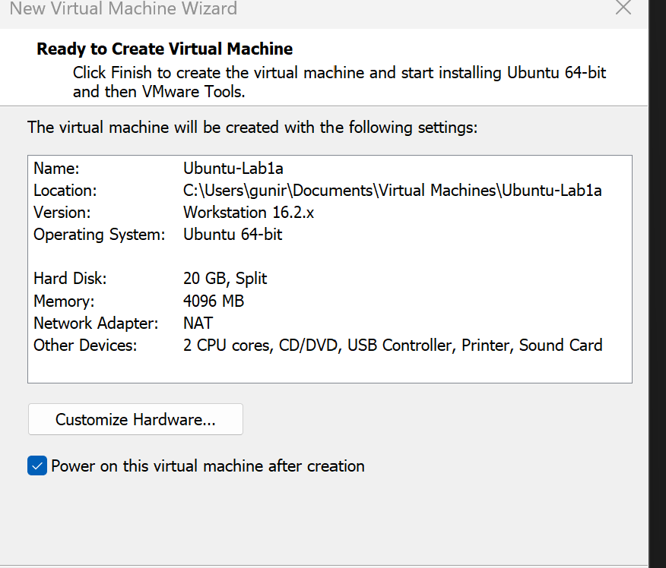

Once the VM is set up, we go through the installation set up process, installation will then proceed and prompted to reboot the system. Then login as the user.

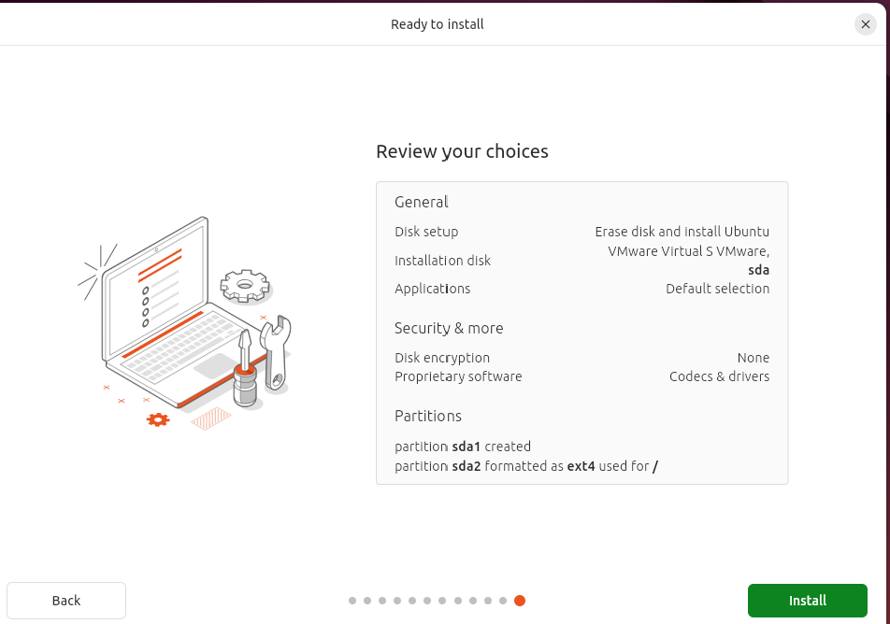

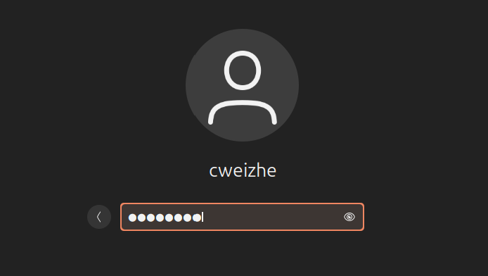

Start with `sudo apt update`, it updates the list of available packages and their versions stored in the system's package index.

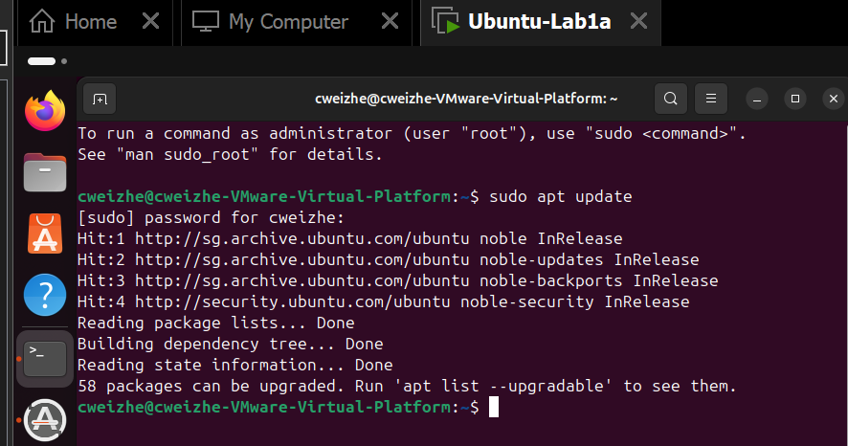

Then I continue to install virtual box guest as this allows automatic screen resizing for VM:

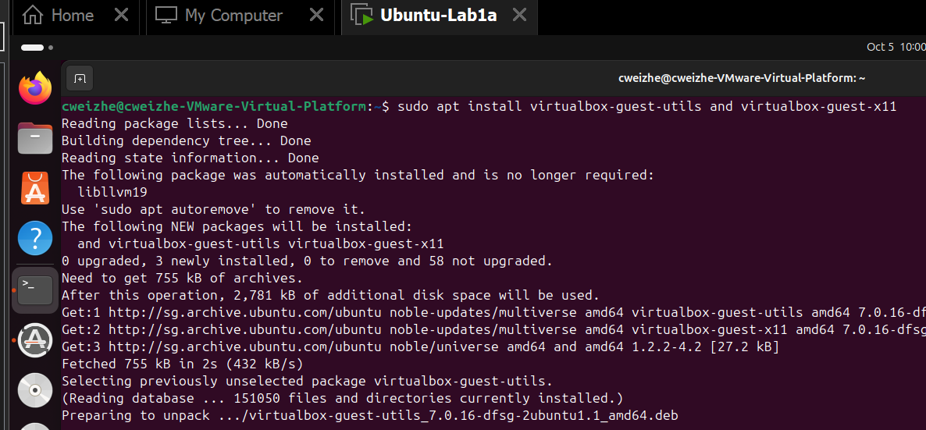

Install SSH using command `sudo apt install openssh-server –y`, followed by `sudo systemctl start ssh`and `sudo systemctl status ssh` to enable it and ensure it is running:

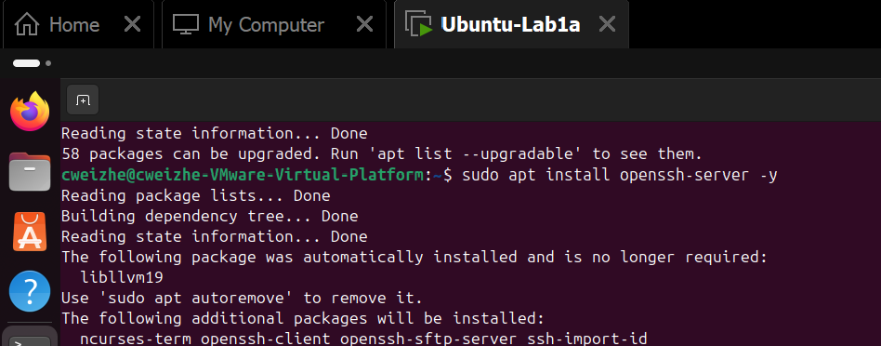

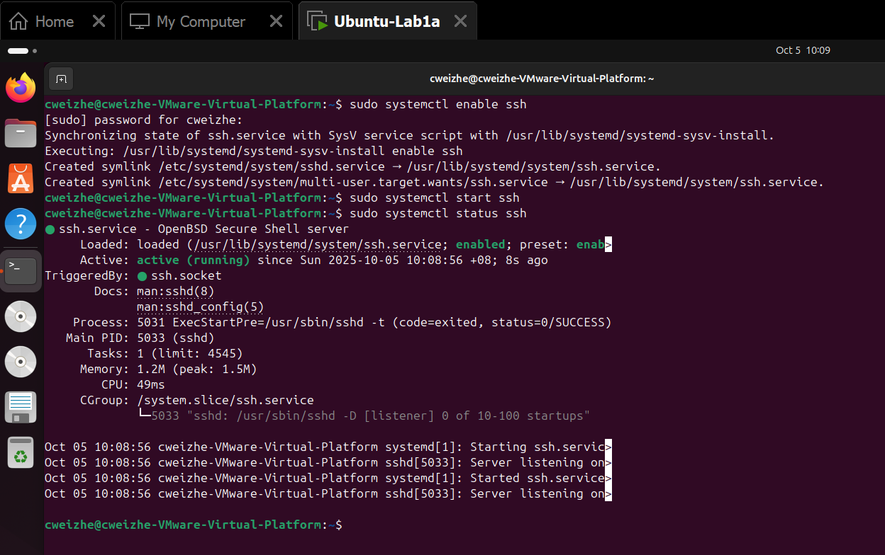

**Lab 1a-2 Ubuntu Desktop and Command Line Familiarisation:**

Part 1: Ubuntu Desktop GUI Familiarisation

* Check Internet using Firefox.
* Open LibreOffice and type a document.
* Navigate directories using File Manager.
* Install a program via Ubuntu Software Centre.
* Visualise file changes by placing terminal and file browser side-by-side.

I have installed using the following command `sudo snap install libreoffice` to install LibreOffice from the terminal.

After the installation, I can then open LibreOffice using the command `libreoffice –writer` from the terminal, LibreOffice will be opened and i am able to write sentences and save it like using a notepad.

There is also a command `nautilus`, it can be used to open the files.

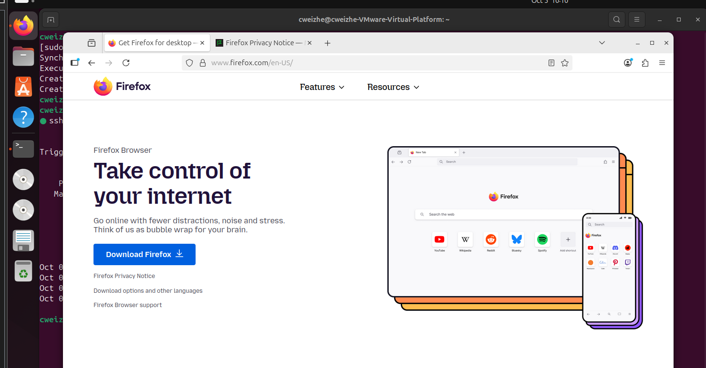

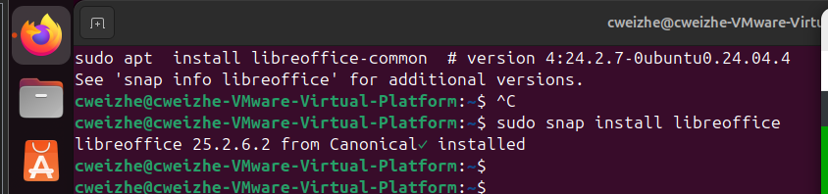

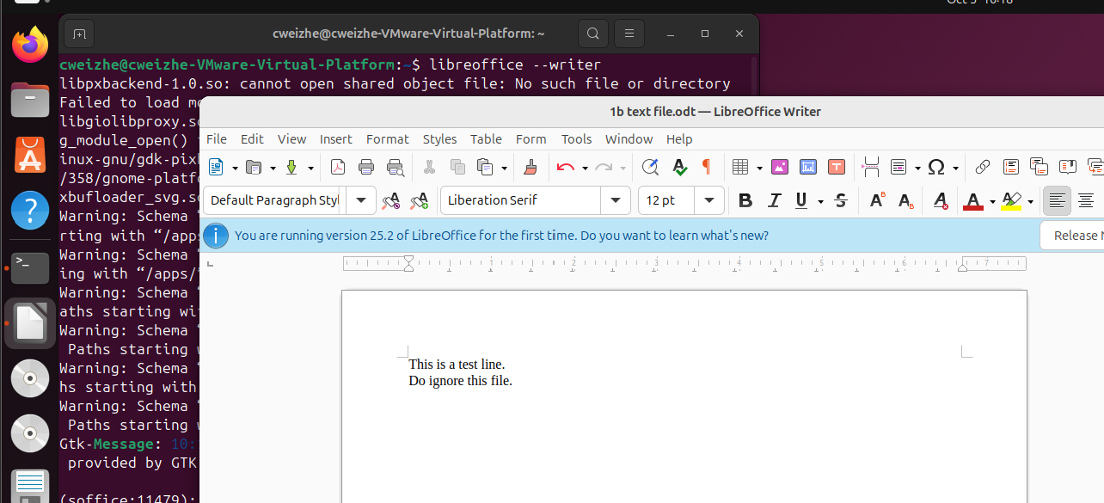

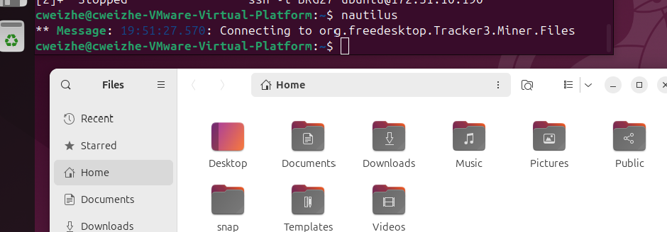

Part 2: CLI Basics and File Operations

* Use ps -e, top, and 1 to monitor processes.
* Use ls, ls -la, ls -alt, ls -lah to explore files.
* Create/edit/view files using touch, gedit, nano, cat, less.
* Copy and move files with cp, mv; delete with rm.
* View system info using uname -a, lsb_release -a, hostnamectl.

The command `ps –e`is used to display the information of all the active processes that are running on this system, sorted by PID.

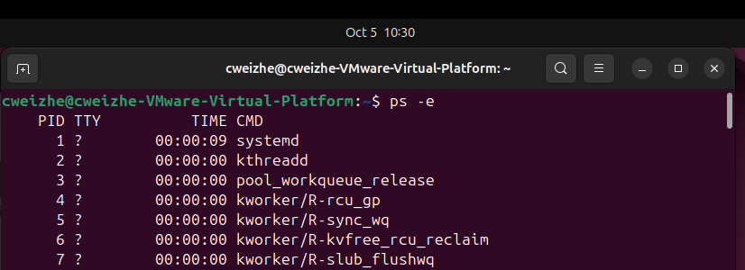

The `top` command displays system summary information and the list of processes or threads that are currently managed by the Linux kernel.

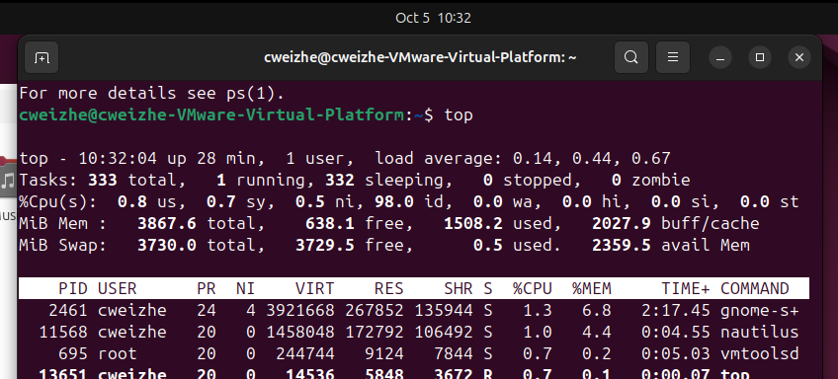

When the `top`command is running and I press 1, the display will change. It will now then display the usage for each individual CPU core.

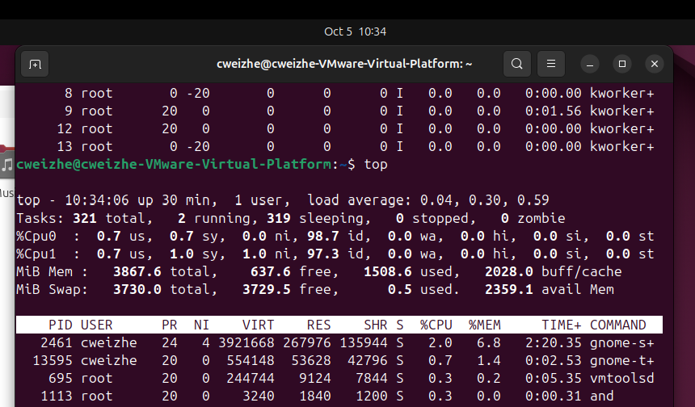

The `ls` command is used to display the files and subdirectories present in the current working directory.

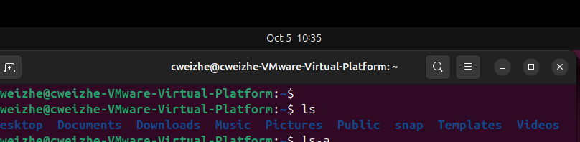

The command `ls –la` will display all the files and directories in the current directory in a long format.

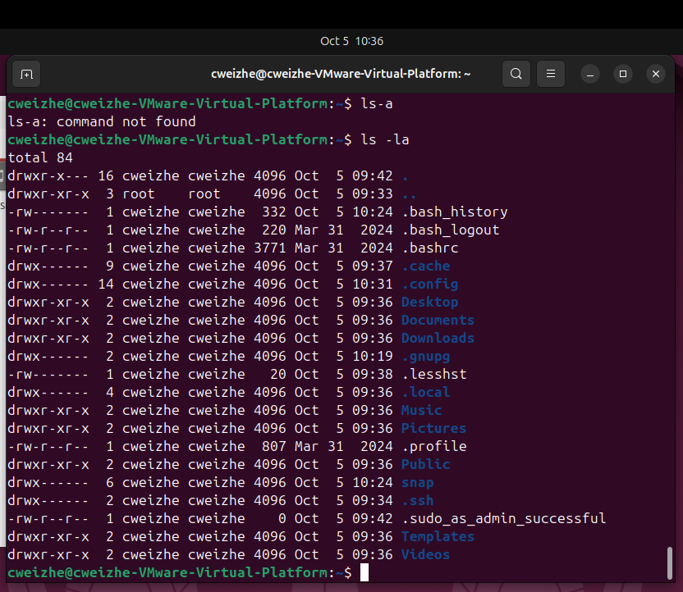

The command `ls –alt` will display all the files and directories in the current directory in a long format and sorted by the newest first.

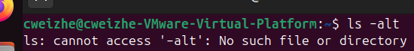

The command `ls –lah` is similar to the command `ls –la`, what it does differently is that it does not show the exact size of the file, for example, 4096 has been shortened to 4.0k.

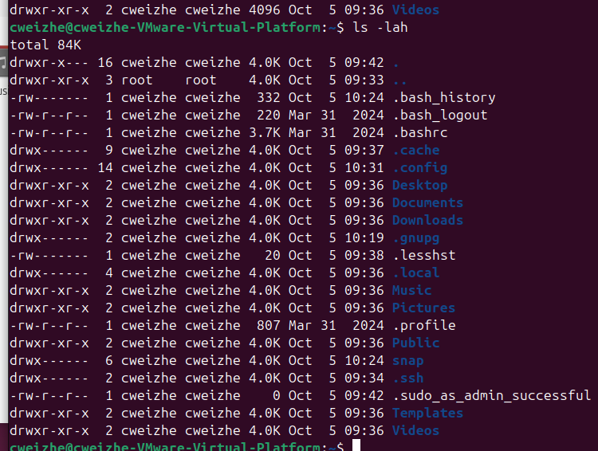

The `touch` command is used to create an empty file while `gedit` is used to open the file with gedit text editor, allows editing and changes can be saved. In the screenshot below, I created file1 with the `touch file1` command and added two short sentences with `gedit file1` command. Apart from it, I also created another empty file named `file2`.

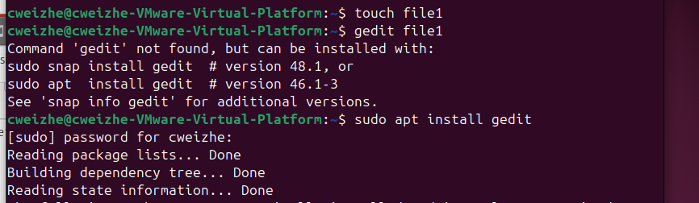

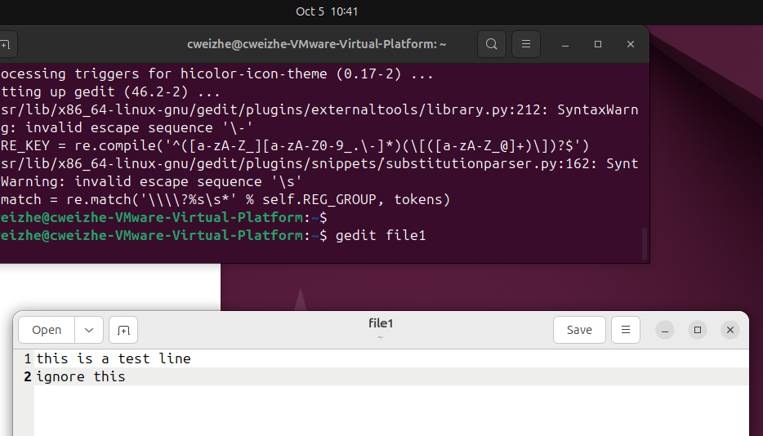

The `nano` command will open Nano text editor that allows the file to be edited directly from the terminal. If I want to save the file that is updated using `nano file1` command, press ctrl and o together, then press enter to confirm the changes made.

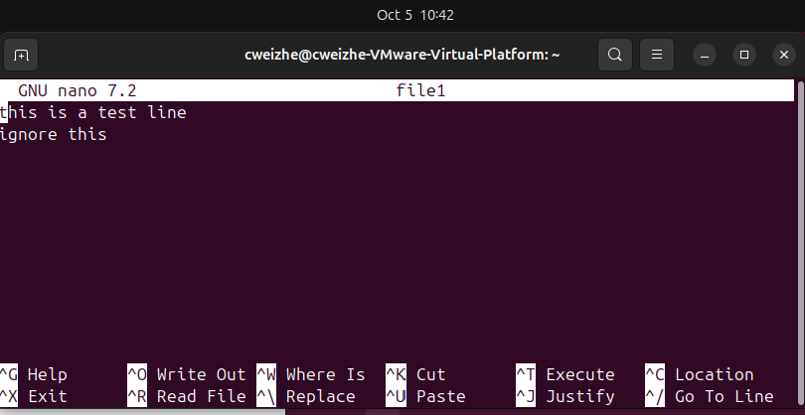

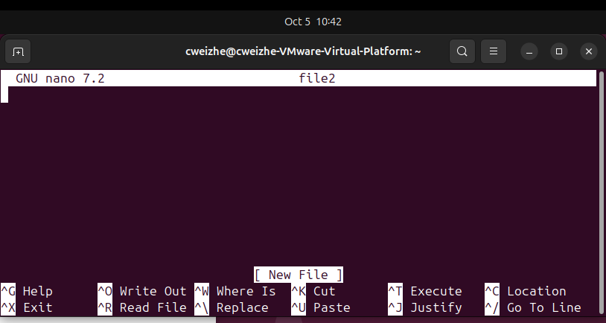

The `cat`command can be used to display the content in the file like how I use for file1 and the empty file2. The `less` command is used to allow users to view the content of a file, `command | less` allows user to see the output of a command.

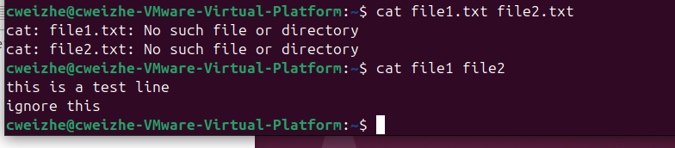

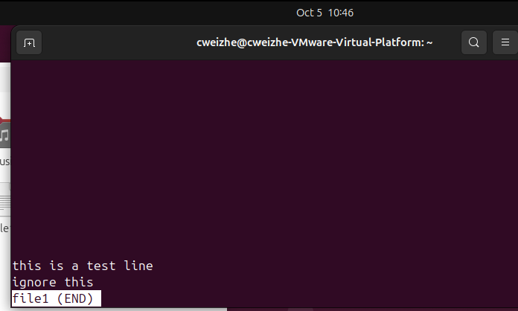

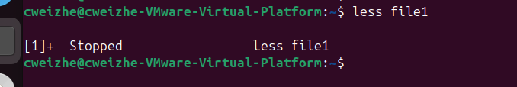

The command `cp file1 copyfile1`make a copy of file1 and name it copyfile1. `mv ` command is used to move the file to another location.

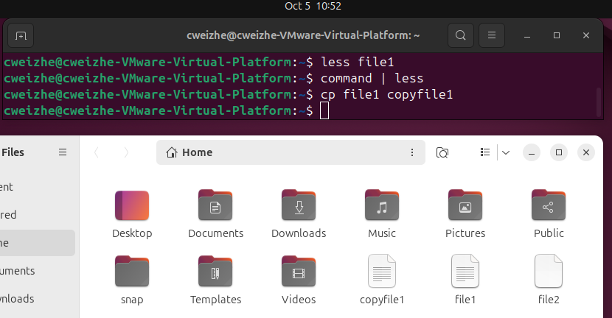

Similarly, I have made a copy of copyfile1 first, then rename it using the command `mv copyfile1 documents`. Then is used the command `mv copyfile1 /home/cweizhe/Downloads` to move the file into Downloads directory.

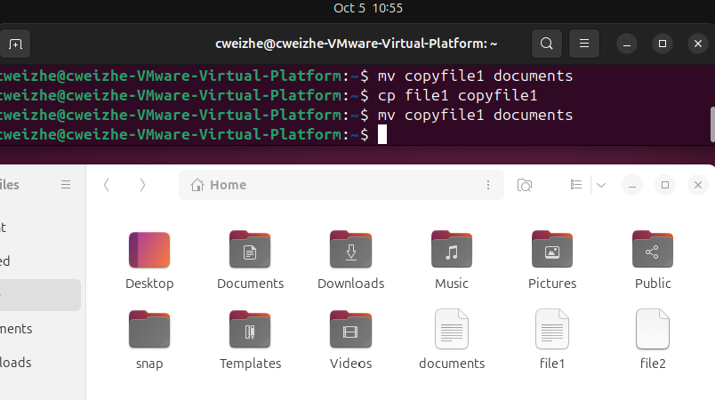

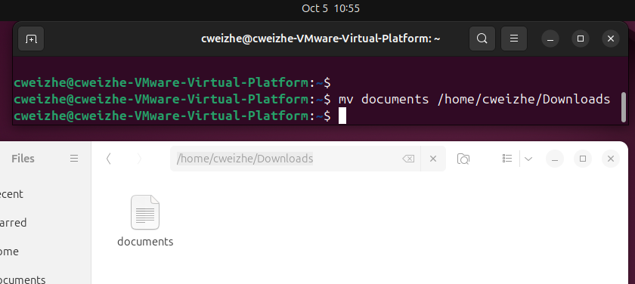

I then use the command `rm file2` to delete the file.

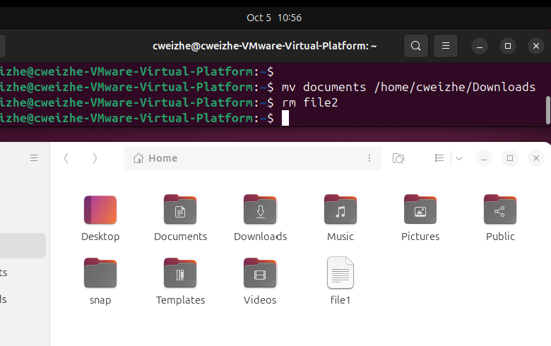

The command `uname –a` is used to is used to display a summary of all available system information. `lsb_release –a` is used to display available information about the Linux Standard Base.

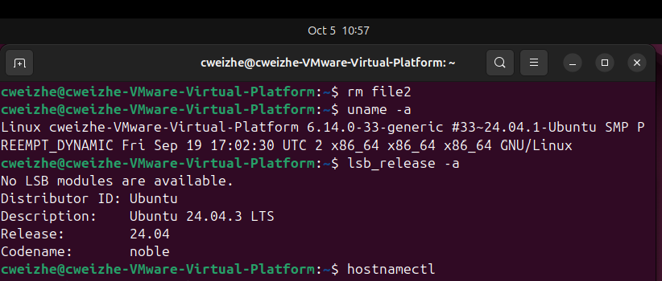

The command `hostnamectl` will show hostname and other system information of the current machine.

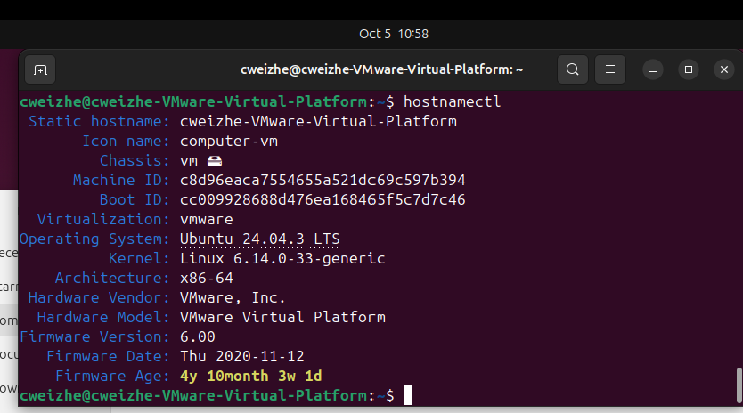

Part 3: Super User and Permissions

* Use whoami, sudo whoami to demonstrate privilege escalation.
* Attempt adduser as sudoregular user, then with sudo.
* Discuss role of root user and best practices for privilege use.

The command `whoami` will show my current username ‘weizhe’, `sudo whoami` shows username ‘root’.

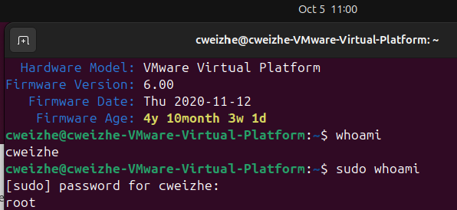

When i tried to add a new user with `adduser `, it will state that only root user has the privileges to operate this command. So, I continued with `sudo adduser testuser1` to create a new user, this time it works.

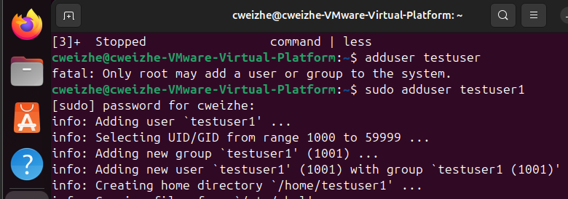

The role of root user is like an administrator that have the highest level of privileges and control within the Linux operating system.

It can execute any command, modify any files, changing the permissions or ownership of files and directories, modify user’s permission on the file.

Part 4: Network Configuration and DNS

* Use ip a to identify private IP.

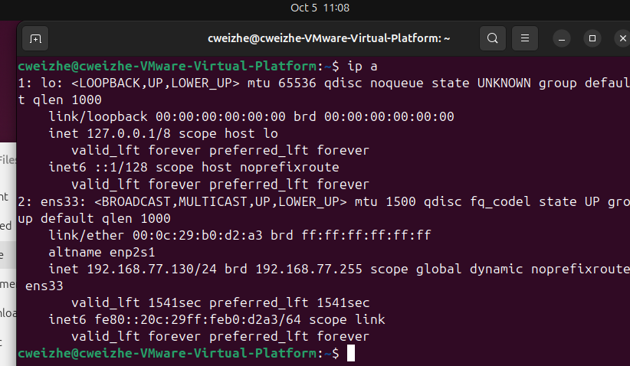

The IP address `8.8.8.8` is the public DNS server of Google.

We are able to ping using both 8.8.8.8 and google.com on the terminal as the ip address is linked to the google.com address.

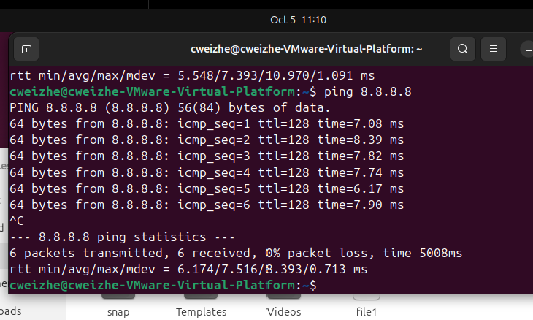

First, I will use `nano` to open `/etc/hosts` and add the ip address and name it ‘dnsgoogle’ inside. So, when I ping ‘dnsgoogle’, it will ping to ‘8.8.8.8’ directly.

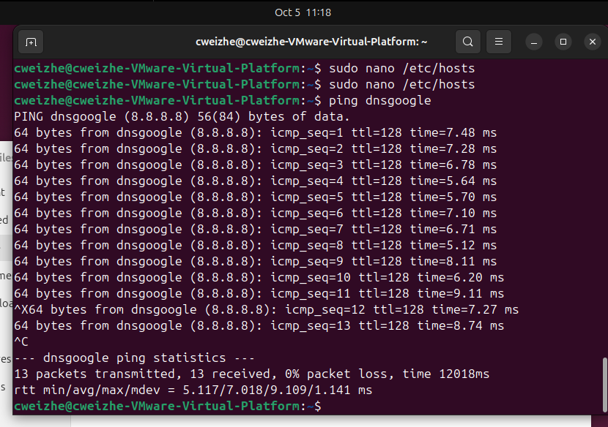

* Use nslookup and install/use whois to investigate domains.

nslookup: 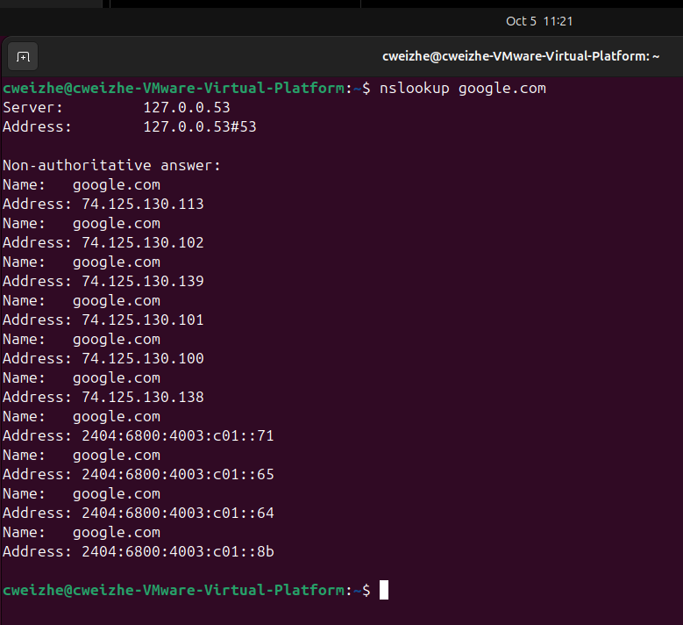

Installation of whois program and check on google domain.

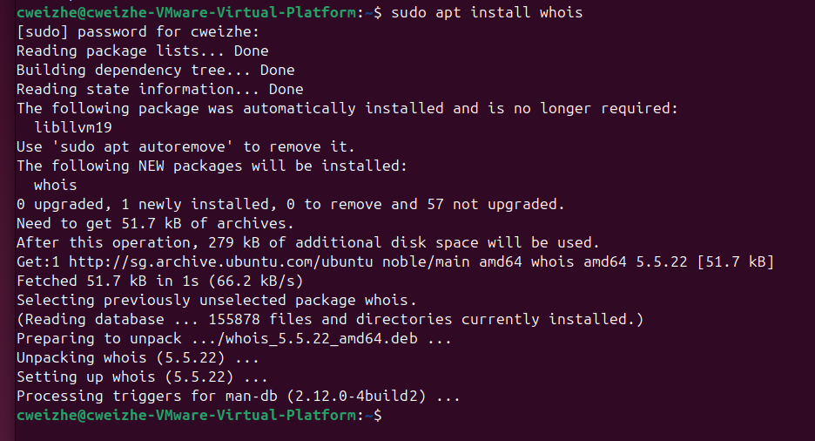

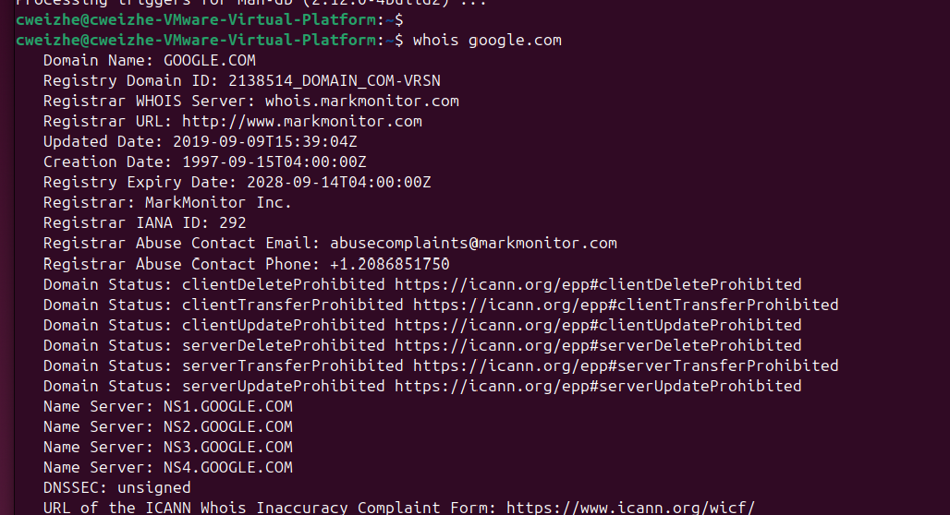

* Compare public/private IP via <https://whatismyipaddress.com/>.

Part 5: System and Hardware Info

* Use lsusb, lspci, less /proc/cpuinfo to inspect hardware.

lsusb and lspci: 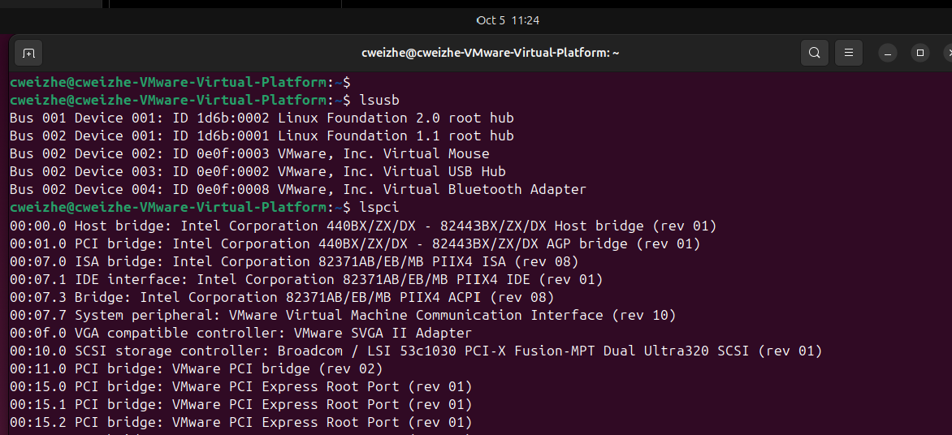

less /proc/cpuinfo: 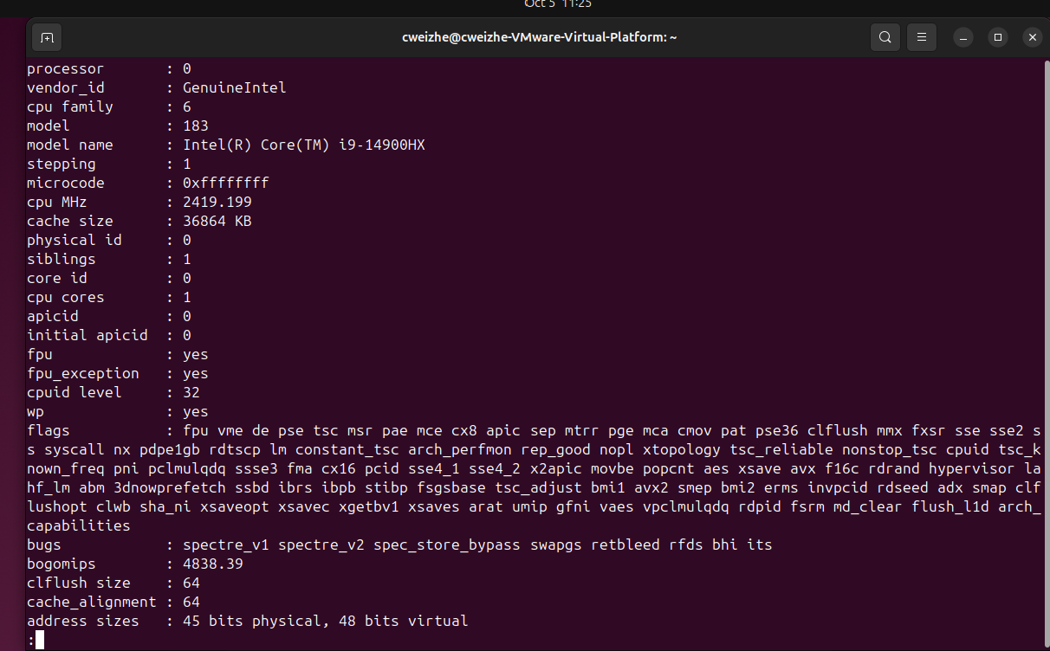

* Compare CLI outputs with 'About This Computer' in settings.

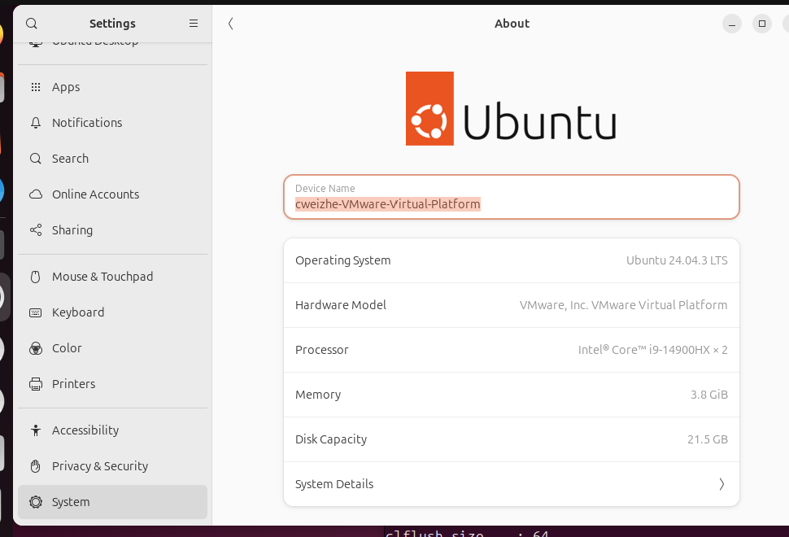

* Redirect output using >, e.g., lsusb > output_of_lsusb, then view with less and cat.

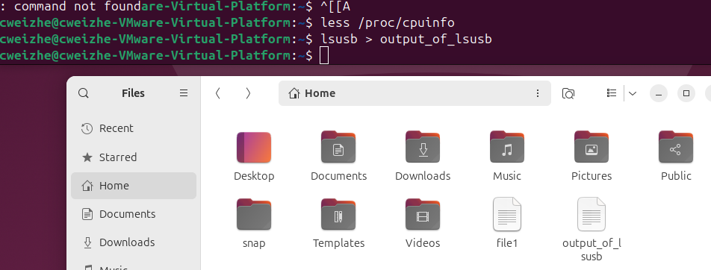

less: 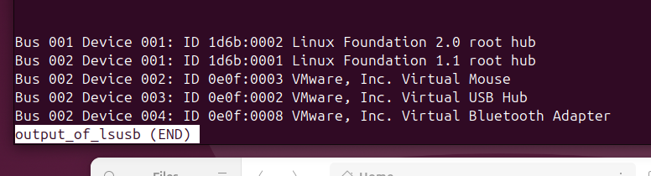

cat: 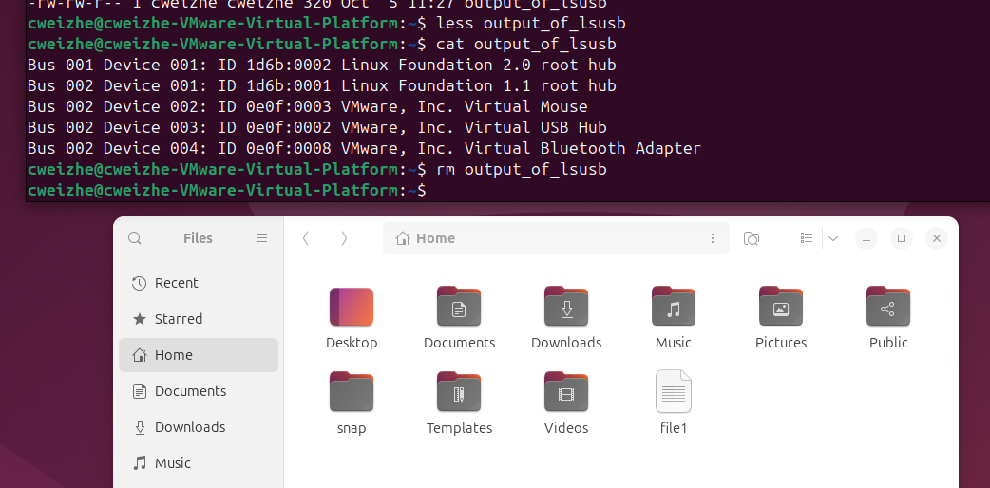

Part 6: Software Installation Methods

* Install a browser (Chrome/Opera) from a .deb file.

To install chrome on Ubuntu, i went to the website and download the deb file, then I install it using the commands in the terminal.

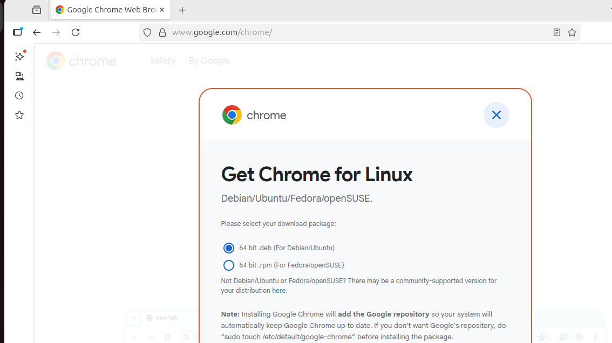

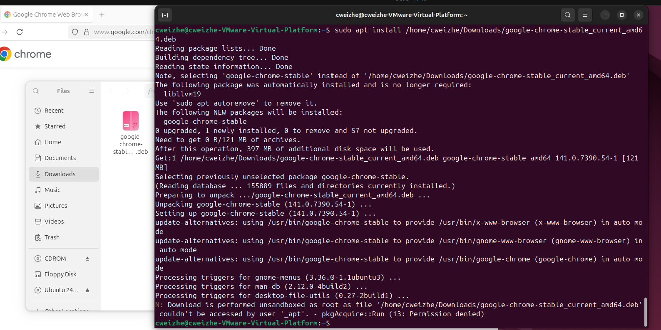

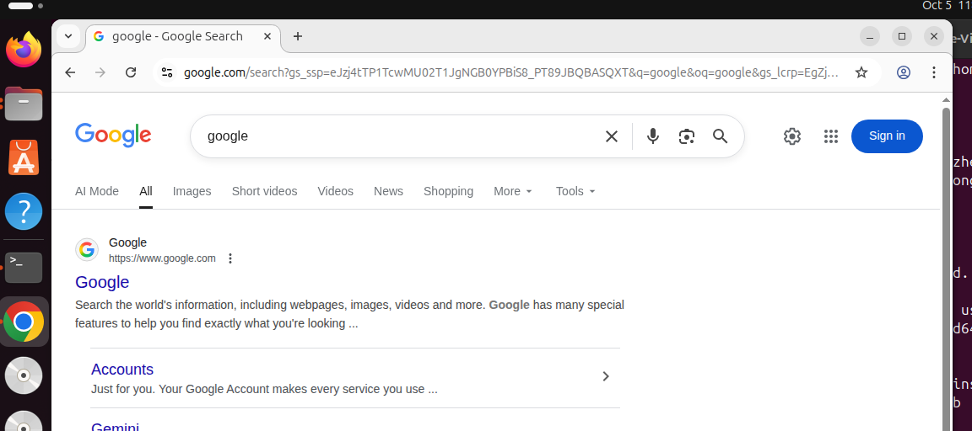

First, I will open the App Center, i then try to download Discord directly, but there is a pop up that asks for the password for authentication before download can start. After input, Discord is able to download and install, the app can also be used.

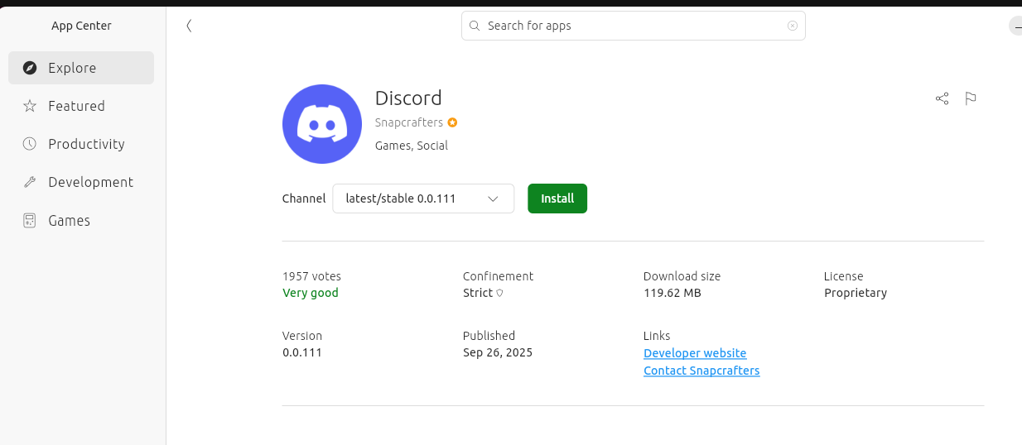

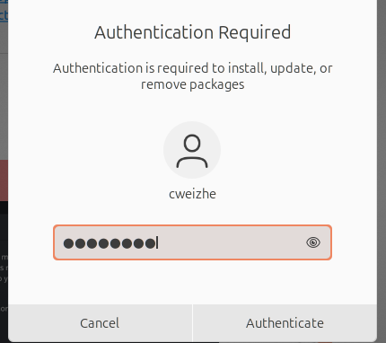

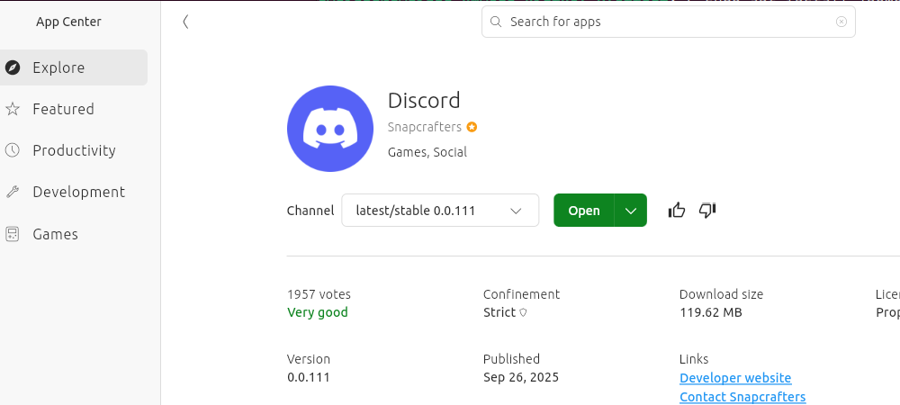

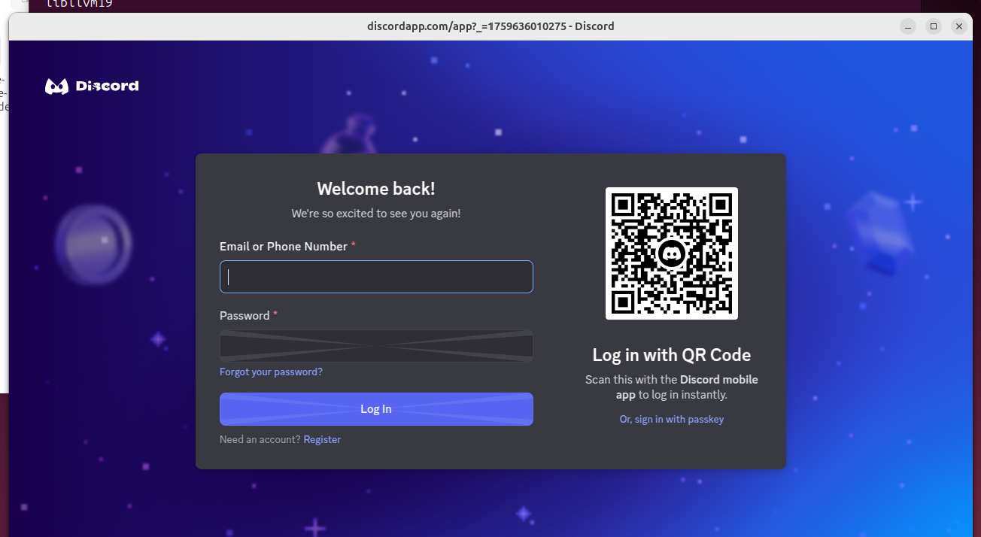

The following screenshots shows the use of the following command:

`sudo apt update` is used to find the latest update list for the packages on the system.

`sudo apt upgrade` is used to install the newer versions of all packages currently installed on the system that are available for update.

`sudo apt install vlc` is used to install the packages for VLC.

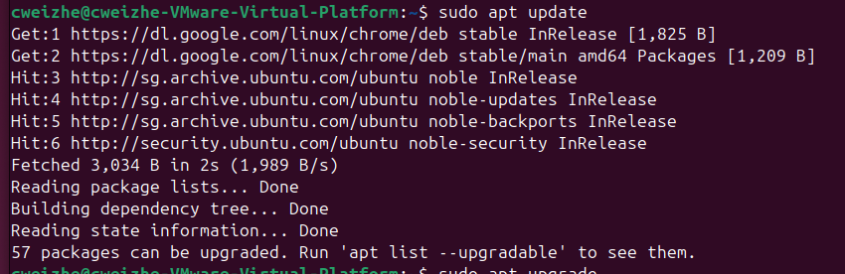

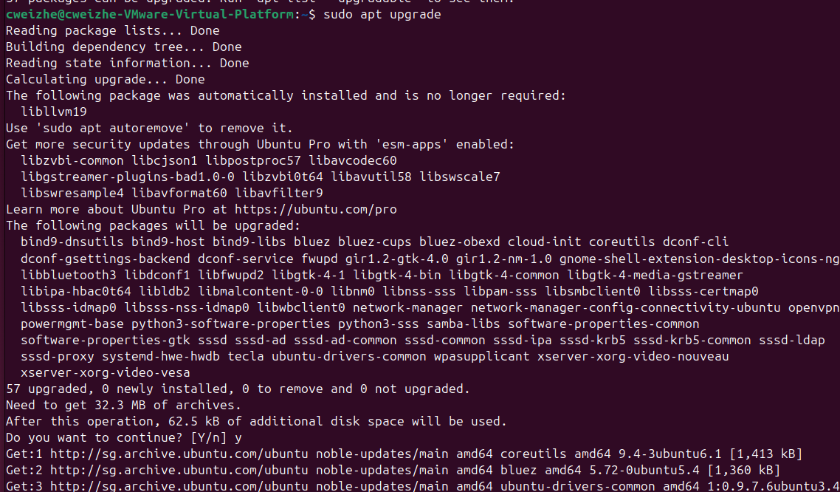

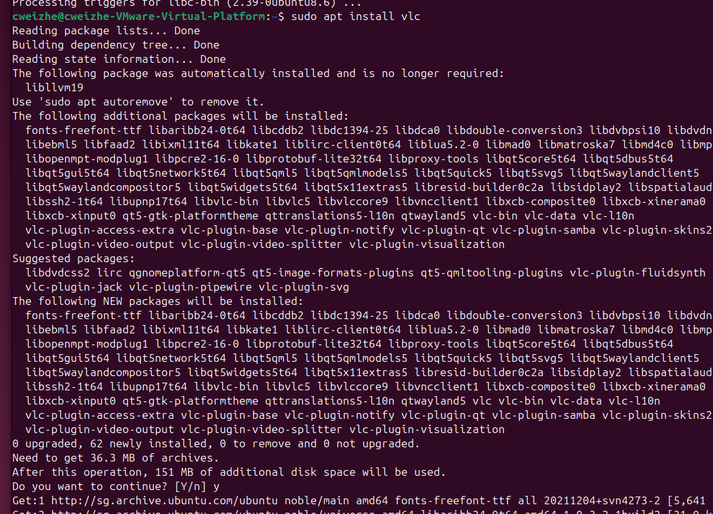

The following command `sudo apt search chrome` is used to fine the available packages and description that match the keyword chrome.

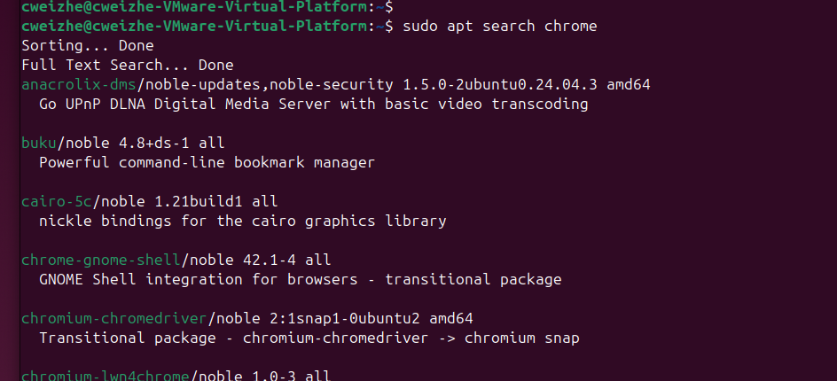

`/etc/apt/sources.list` is used to find the repository where the packages can be found.

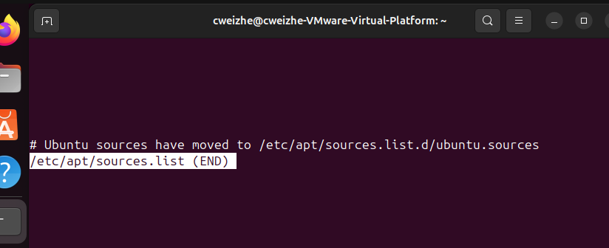

Part 7: Compiling from Source (Optional)

* Install build tools: sudo apt install build-essential.

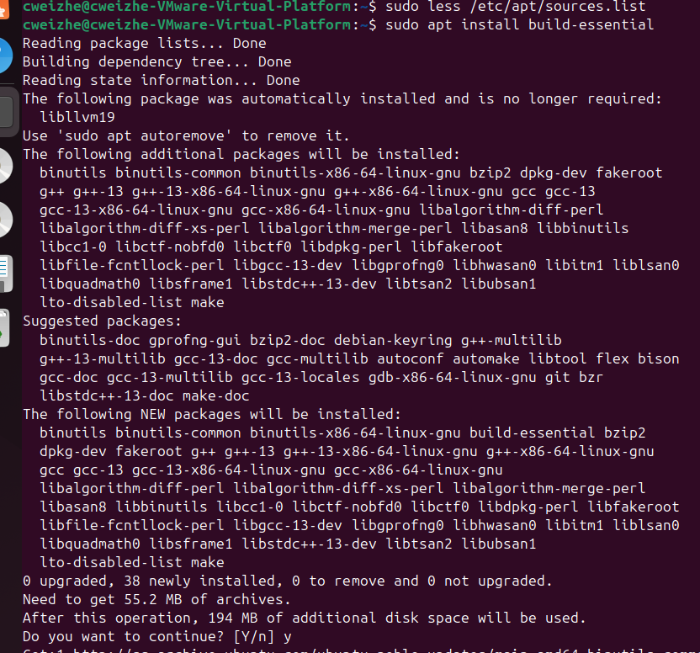

* Write a basic hello_world.c and compile with gcc.
* Run the executable with ./hello_world_executable.

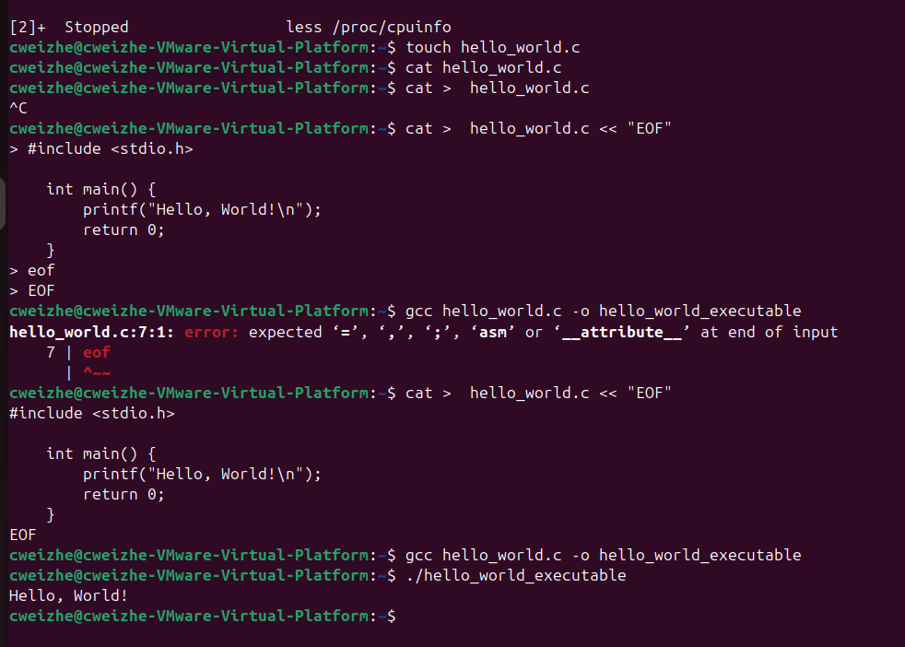

* Adjust permissions with chmod 777 if needed.
* Compare source and compiled file using less.

I am able to see the source script directly using the `less hello_world c` command.

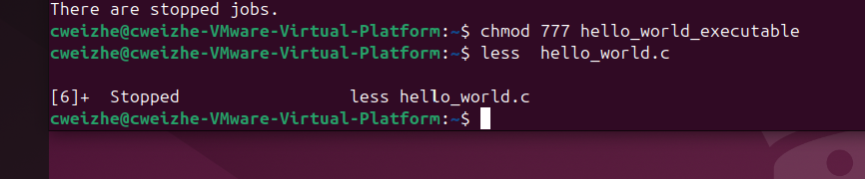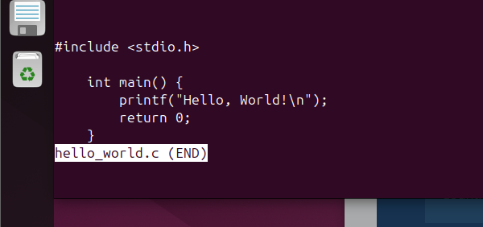

But when it comes to the compile file, it will show a prompt to ask if I want to see it and this is the output.



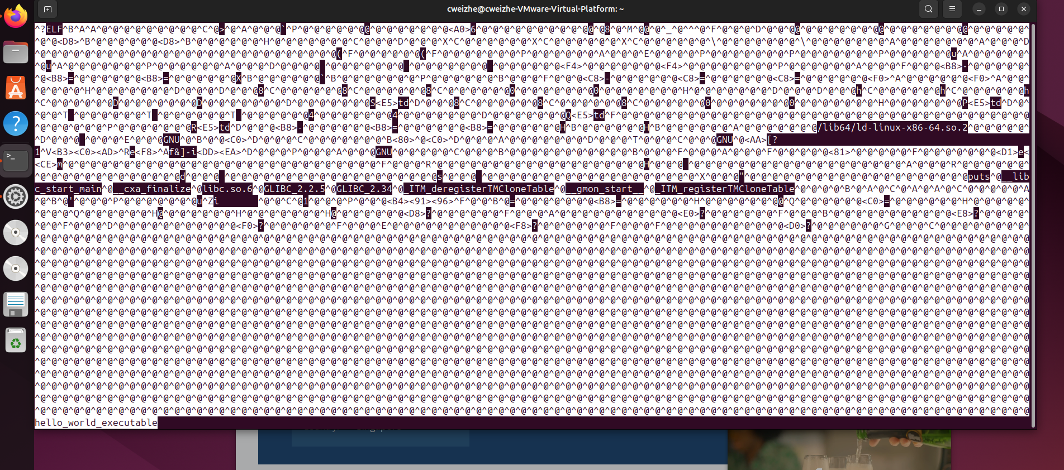

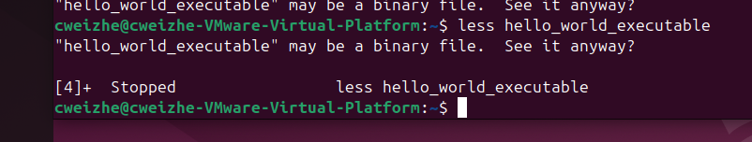

* Which file editors are best for remote access and why?
* Compare software installation methods: SaaS vs binaries vs repos vs source.
* What are pros/cons of each method from user and developer perspectives?
* How did using CLI improve your understanding of Linux?

I would say that Nano is the better file editor as it can be open from the terminal directly for edit, it is more user friendly for beginners.

#### GitHub Usage

GitHub is a cloud-based platform that enables the developers to store, manage, collaborate on code and other projects. In addition, it can also be used as a place to store notes. In GitHub, I have created a public repository that allows anyone to access it.

### 3. Linux Services, Permissions, and Bash Scripting

#### Service Configuration and User Permissions

* Services installed (e.g., NGINX, SSH).
* Permission controls (e.g., chmod, chown, usermod).
* Lessons learned on least privilege and access control.

#### Scripting and Automation

* Purpose of your script (e.g., log backup).
* Cron job setup and testing process.
* Reflection on debugging and improvements.

Lab 1b-1:

For lab activity 1b-1, I have installed Apache2 using this command `sudo apt install apache2`, Using the ip address for localhost, `127.0.0.1`, I managed to access Apache2. Next, I continue used the command `ip –a` and retrieved 2 set of ip address,

Lab activity 1b-2:

Linux uses 3 main permissions, read, write and execute which implies to the owner, group and other users,

Windows uses Access Control Lists (ACL) controls which user or group have what type of permission for that file or folder

# **Lab Activities**

* - Install Apache using `sudo apt install apache2` and test `http://127.0.0.1`.
* - Install SSH server and Nmap: `sudo apt install openssh-server nmap`.
* - Determine IP using `ip a` and visit peer web page in browser.
* - Edit index.html using nano/gedit and share unique changes with partner.
* - Scan each other's ports using `nmap [IP]` and note open services.
* - Remove Apache and rerun `nmap`; reinstall and observe differences.
* - Enable UFW with `sudo ufw enable`, allow port 80, and observe service access.
* - Attempt `ssh [partner_ip]`, troubleshoot with UFW rules.
* - Create a new user: `sudo adduser username` and SSH using `ssh username@ip`.
* - Download books from Project Gutenberg using `wget`.
* - Create directory `books`, move files, create tar: `tar cf books.tar books`.
* - Compress with `bzip2 books.tar`, decompress with `bunzip2`, extract with `tar -xvf`.

The following screenshots are the tasks that were completed for this workshop activity 1b-1.

The first one is installing apache2 using the commands and test that it will open on the browser when the IP address is typed.

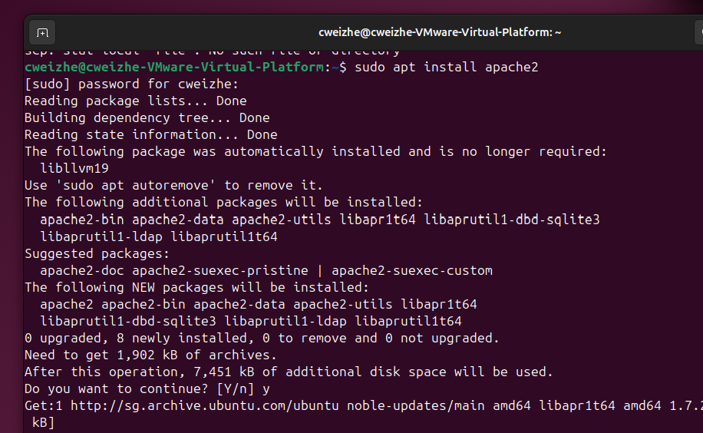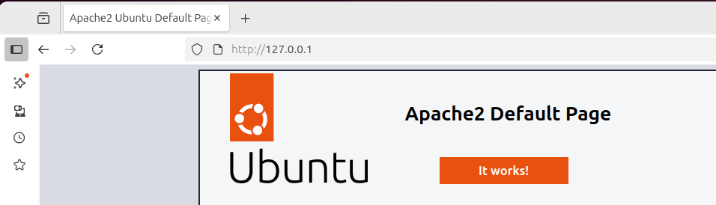

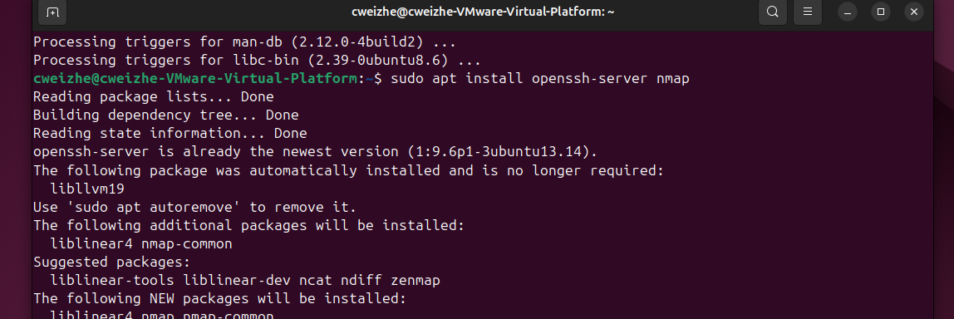

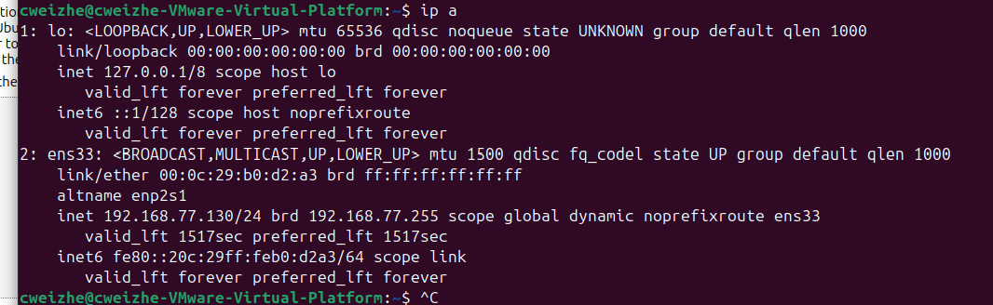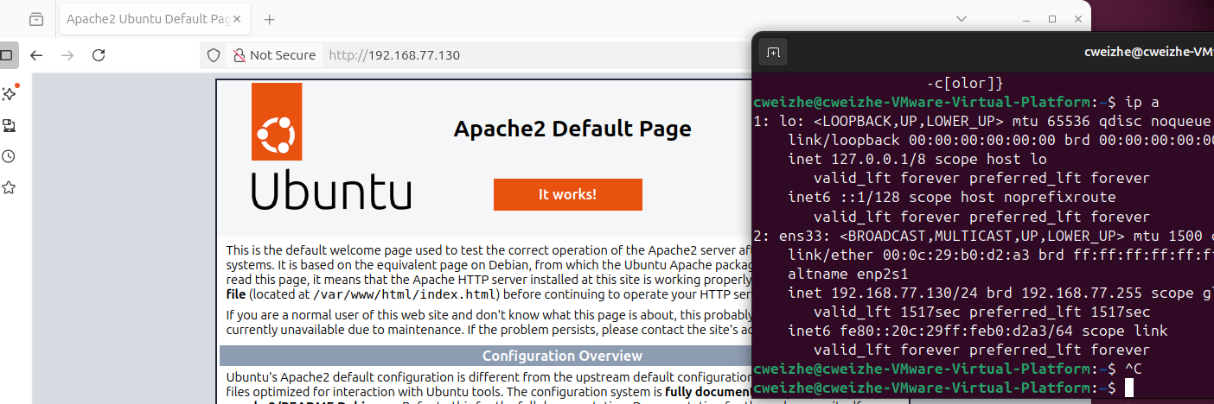

Nano allows user to edit the file on the terminal itself while gedit will show a GUI that allows user to edit and save like using a notepad.

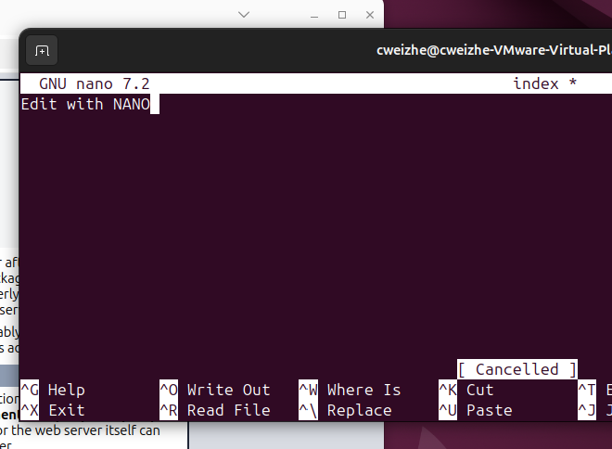

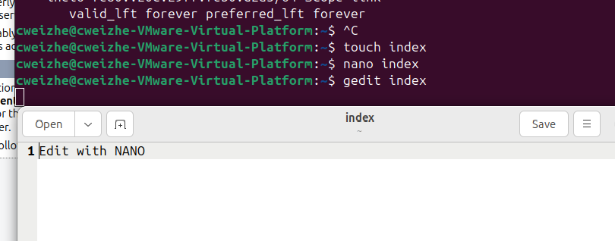

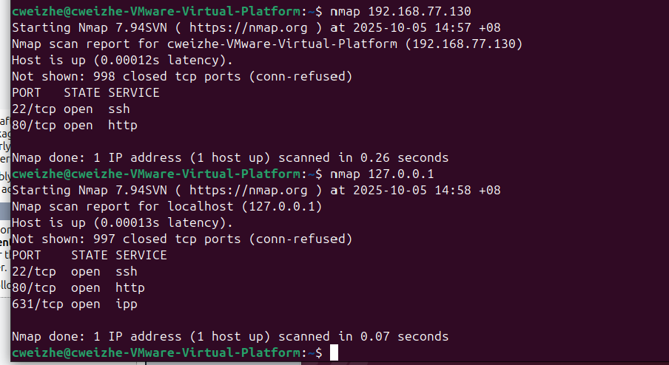

After Apache has been removed, port 80/tcp service will be open and available for other applications to use and will not be shown under these 2 IP addresses. Once I reinstall Apache again, port 80/tcp service will be configured again.

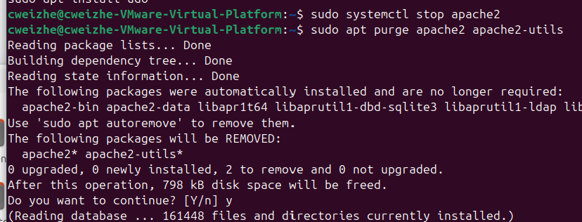

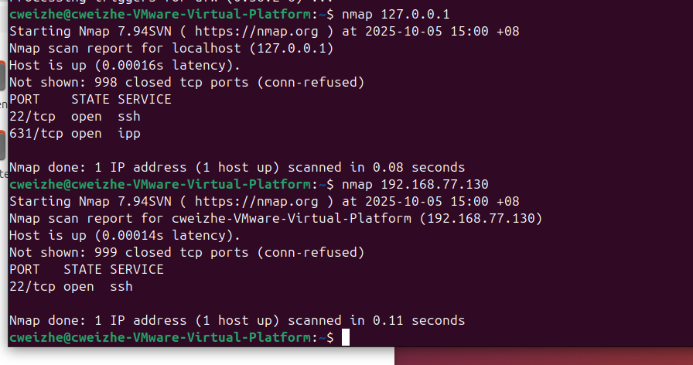

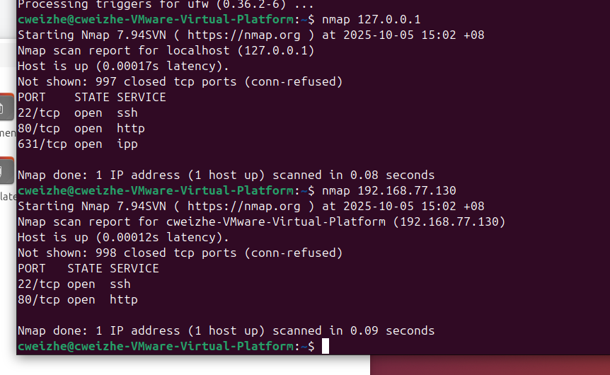

When ufw for port 80 is enabled, it allows connections for IPv4 and IPv6 to be available.

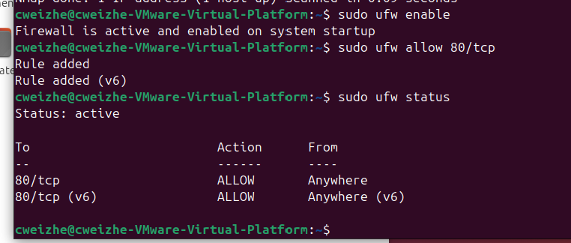

I tried to use `ssh 192.168.77.130` to access with the IP address, followed the prompt, allowing the connection to be made. Afterwards, ssh connection has success.

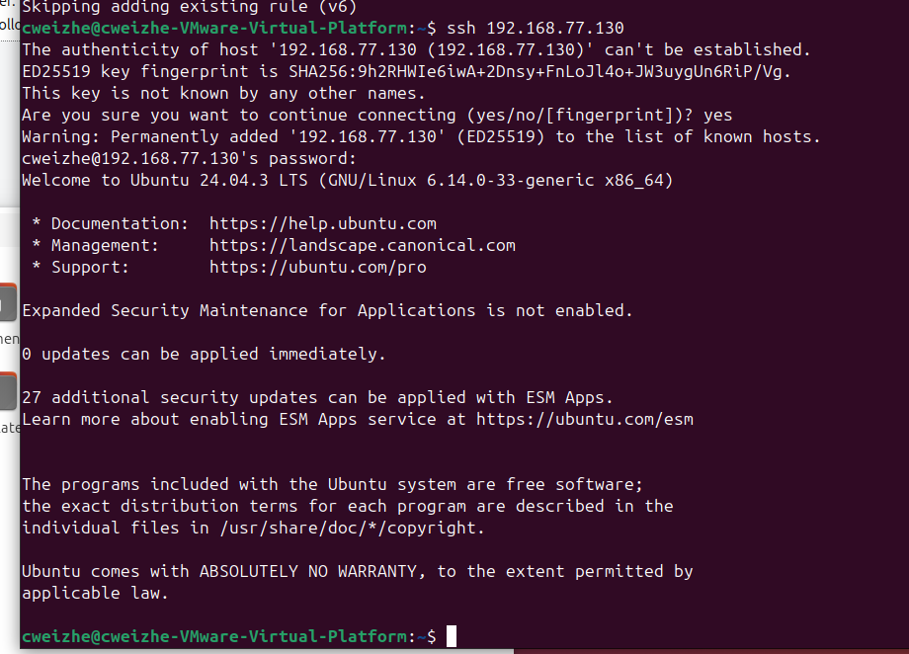

The new user ‘testuser’ is created first with `sudo adduser testuser`, then establish ssh connection using the username and IP address, the username on the terminal will become 'testuser’. This means that I am remotely controlling the targeted user.

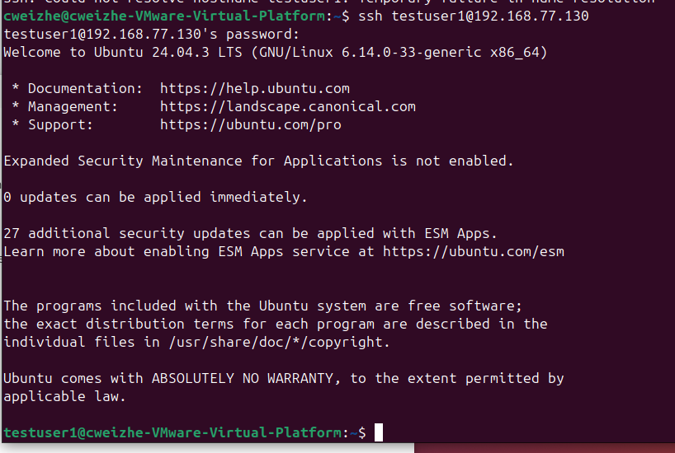

* - Download books from Project Gutenberg using `wget`.
* - Create directory `books`, move files, create tar: `tar cf books.tar books`.
* - Compress with `bzip2 books.tar`, decompress with `bunzip2`, extract with `tar -xvf`.

I have used this command `wget -w 2 -m http://www.gutenberg.org/robot/harvest` to download the books from the website. `-w 2` is to set the delay of 2 seconds for each book downloaded. Afterwards i created a new directory ‘book’, then

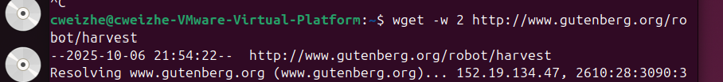



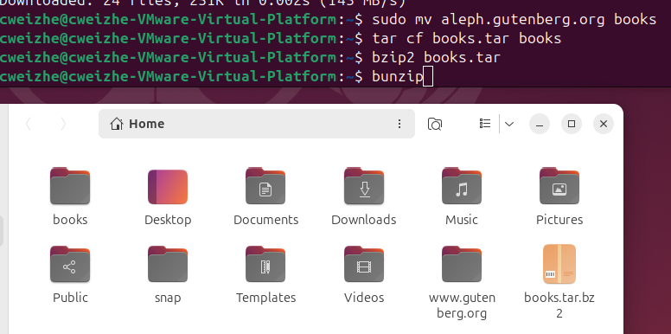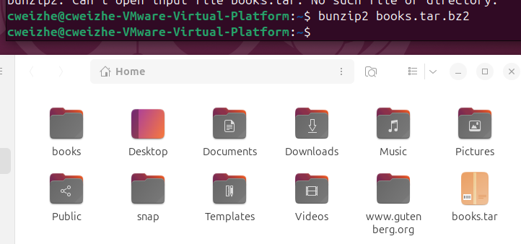

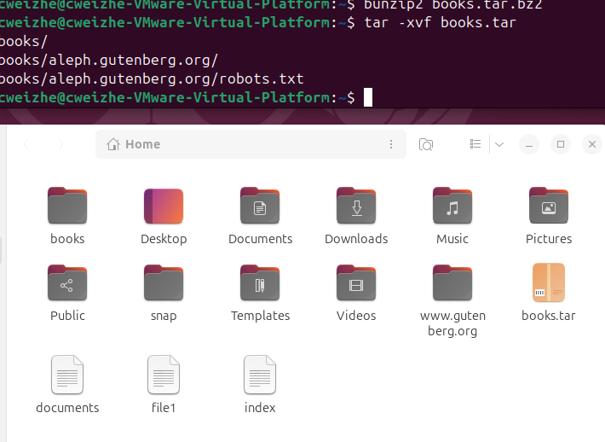

# **Virtual Networking**

* - Clone the VM in VirtualBox (must power off first).
* - Add a NAT Network via File > Preferences > Network in VirtualBox.
* - Set both VMs to use the same NAT network adapter.
* - Boot both VMs and check IP with `ip a`.
* - Fix MAC conflict if IPs are the same by regenerating MAC address.
* - Ping between VMs and test SSH connectivity.

First, I will power off the current VM that I am using to clone it. Then I will open both VM together and use the command `ip –a` to check their ip address. Afterwards, i will start to ping the IP address of ‘Ubuntu-L1’ to the clone, the ping from the clone to ‘Ubuntu-L1’. The result on both VM shows that it is successful.

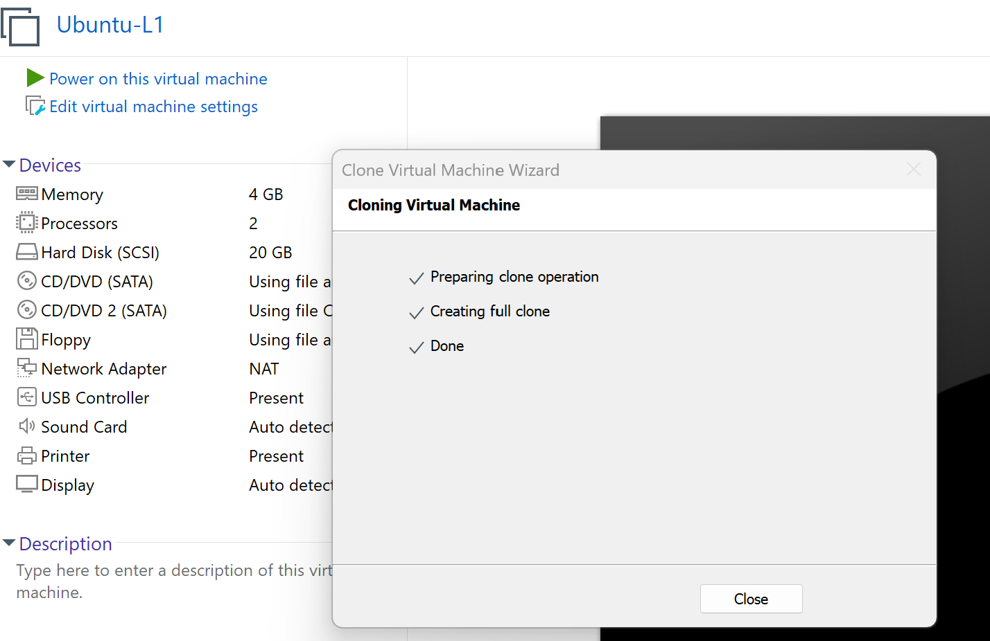

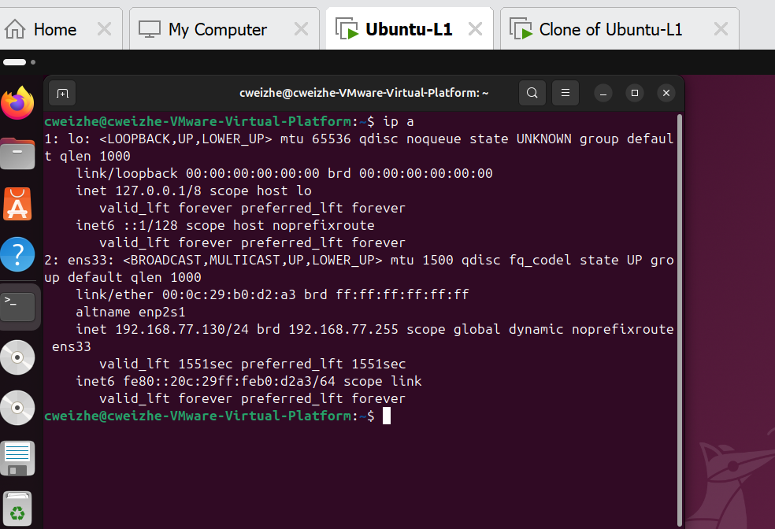

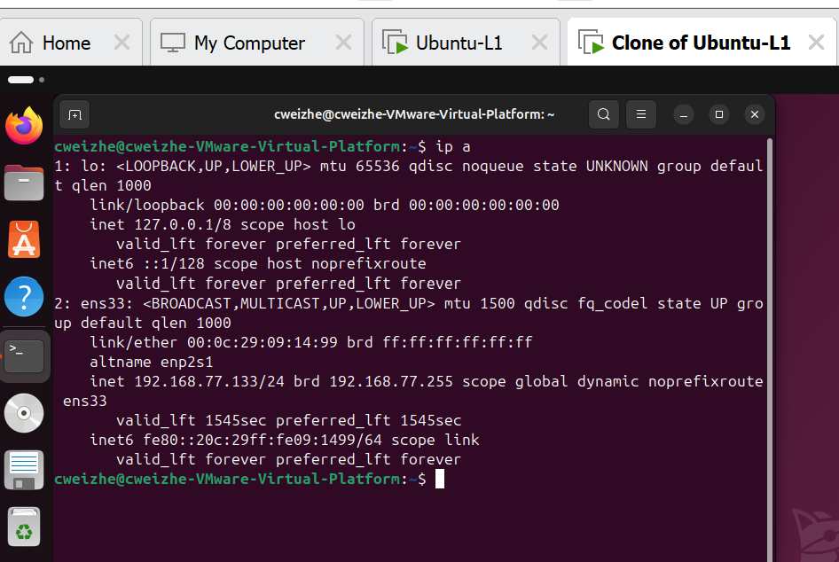

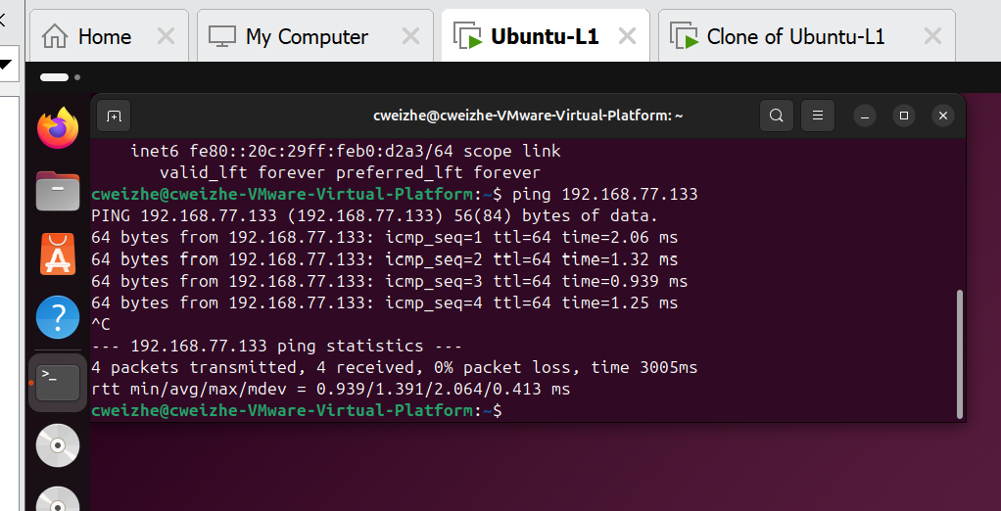

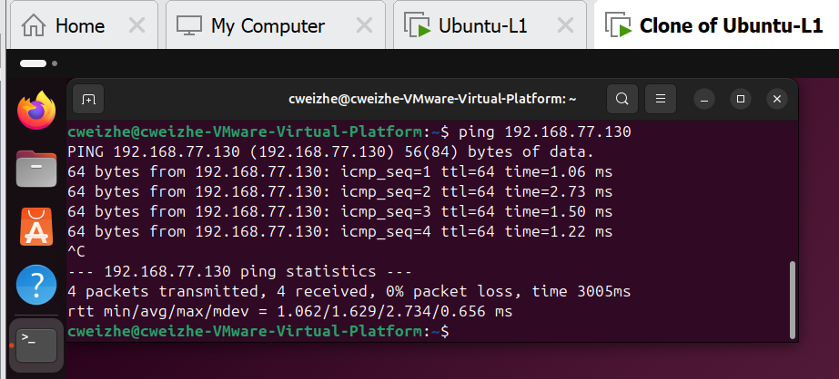

### 4. Cloud Infrastructure and TCO Analysis

#### Cloud Deployment

* Which platform you used (AWS/Azure/DO).
* Steps taken to configure your cloud VM securely.
* Reflection on cloud infrastructure provisioning.

For cloud infrastructure, I have decided to use Amazon Web Services (AWS). as it provides free $100 USD credits, $20 USD for each completed for exploring the functions of AWS.

For cloud infrastructure, it does not use a pricing scheme known as pay-as-you-go, which users only need to pay for the use o

One that I have encountered is that when the VM has been left for a while without being used, it will not be able to do any configurations. Thus I need to refresh the entire web page to continue using it.

#### Cost Analysis

* Summary of TCO comparison across providers.
* Criteria considered (cost, flexibility, scalability).
* Your platform recommendation and why.

TCO means Total Cost of Ownership, which consist of Acquisition cost like the physical hardware, software,

For this process, we will usually research for 2 or more brands to research and analyse, the result after the we list down price of the things we must consider will be used for our decision making.

For this scenario, I will be comparing two different brands of printers with an assumption that the printer will be used for 5 years, 750 pages to be printed per week, power on for 40 hours per week.

We have to consider things like:

Type and price of the printer, what functions do the printers have, cost of the cartridges, maintenance fee, price of paper, price of cartridges, maintenance fee and etc.



2b-1 Cloud Web Server Deployment with Amazon EC2

# **Lab Setup and Execution**

* - Log in to AWS EC2 Console and create a new Ubuntu 20.04 instance (free tier eligible).
* - Name the security group 'ssh-and-web' and allow both SSH and HTTP traffic.
* - Download key pair and save safely. Use this for SSH login via terminal.
* - Connect to the VM using provided SSH command (`ssh -i key.pem ubuntu@IP`).
* - Run `sudo apt update` and install Apache using `sudo apt install apache2`.
* - Access the server using its public IP in a browser (via HTTP).
* - Modify `/var/www/html/index.html` using nano and test the changes live.
* - Download and copy files to `/var/www/html/` using `wget` and `sudo cp`.
* - Create hyperlinks in `index.html` using anchor `<a>` tags.
* - Test access using different devices and browsers.

Before creating a new instance, we need to set up the security group name 'ssh-and-web' and to enable both SSH and HTTP traffic. Click on ‘Create Security Group’, name it 'ssh-and-web', the description will be ‘To allow SSH and HTTP traffic’, VPC leave it as default, then add the rule for inbound rules. Create 2 inbound rule, one for SSH and the other for HTTP, put `0.0.0.0` for the CIDR blocks. Then create it.

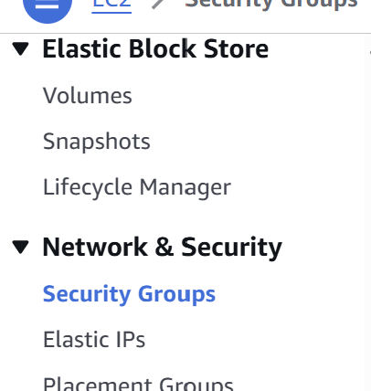

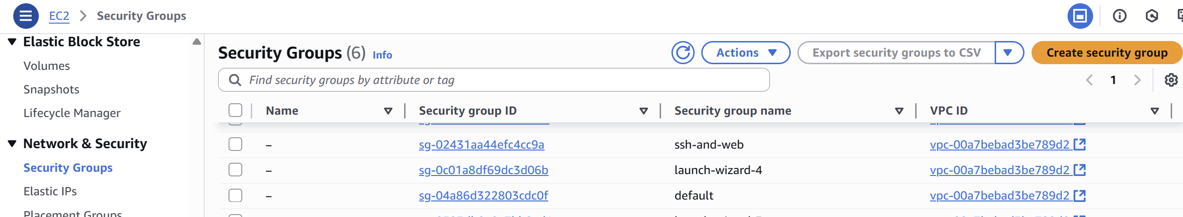

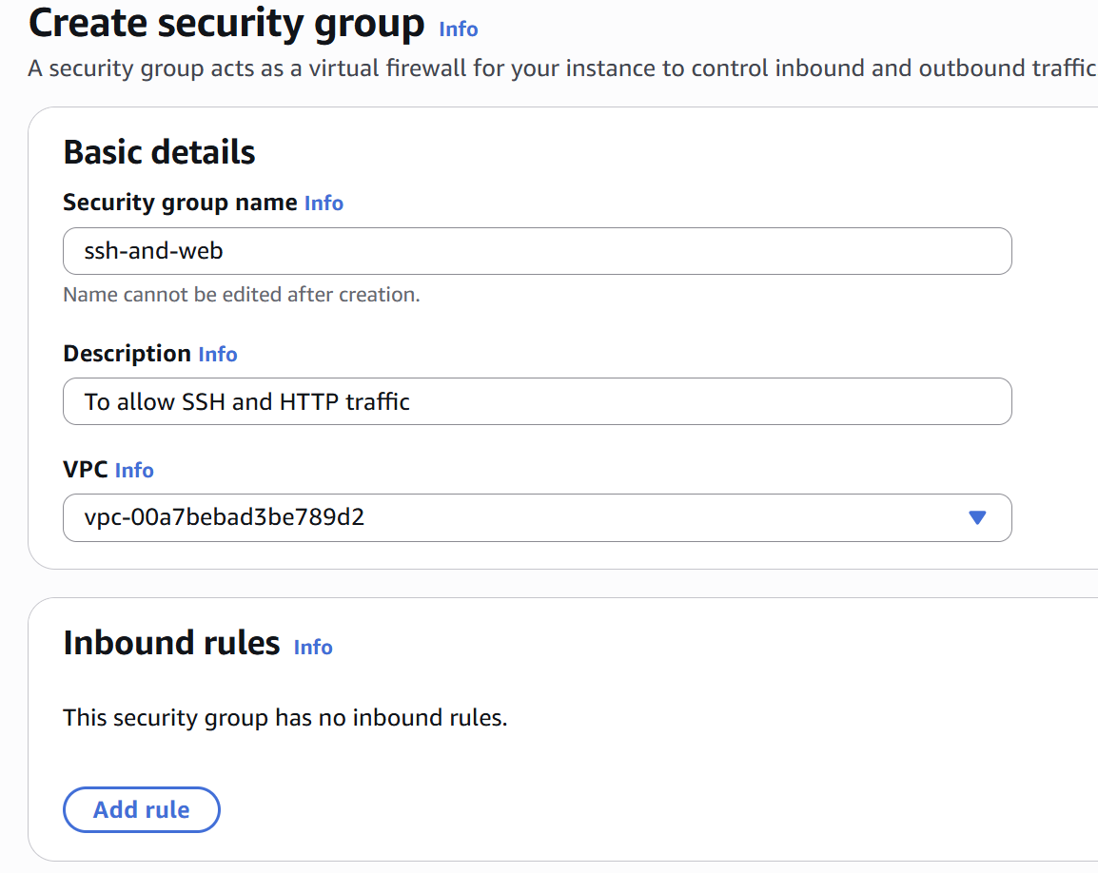

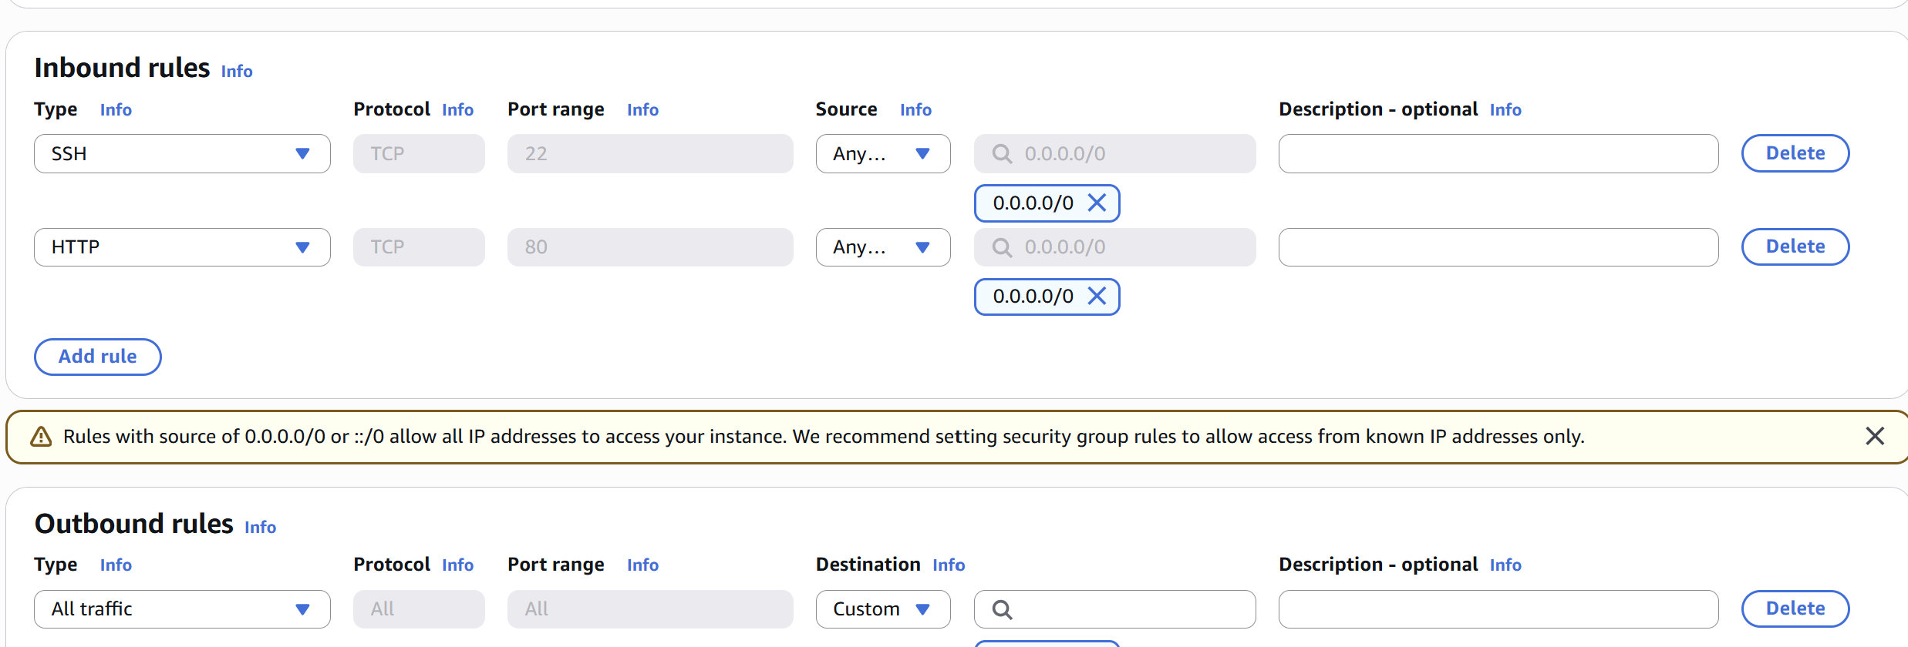

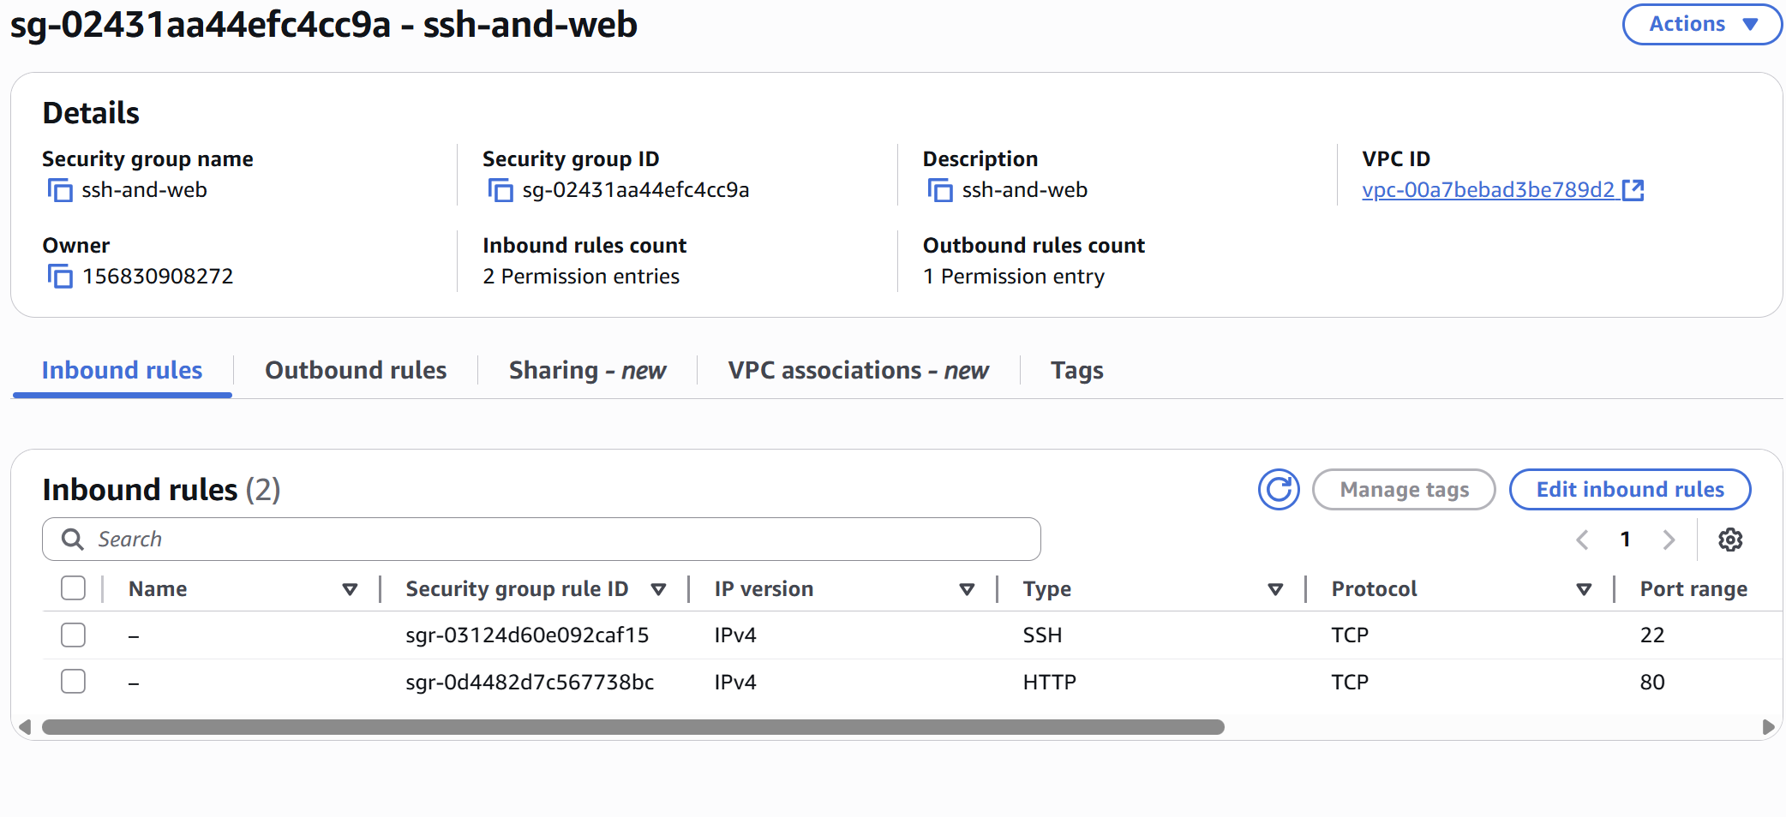

When creating a new instance, it requires a name for it, selecting the image that will be used, Ubuntu 20.04, then name the Key Pair as ‘BRG27’, security group choose ‘ssh-and-web'.

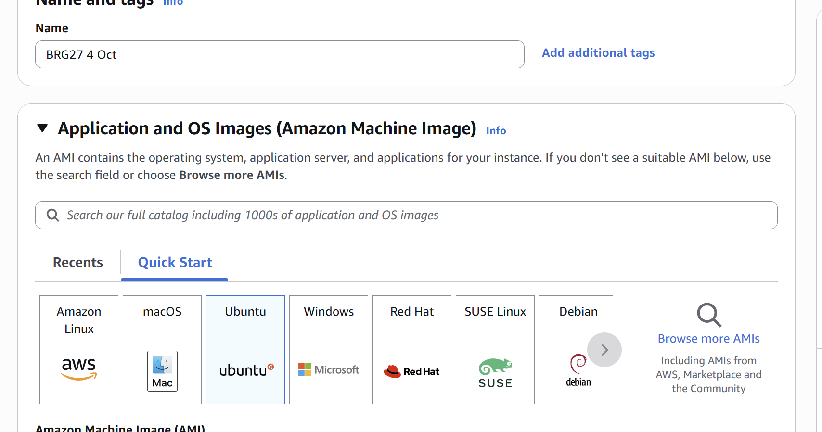

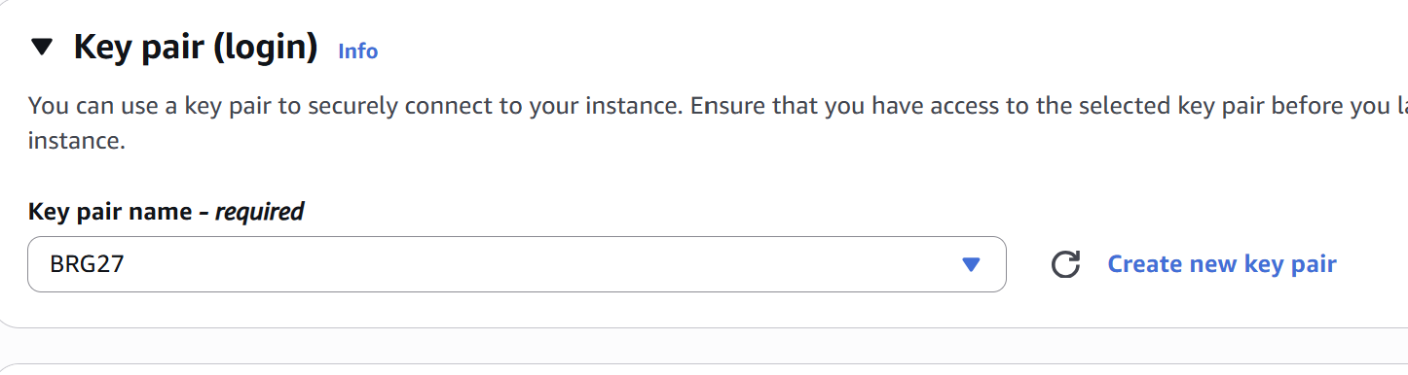

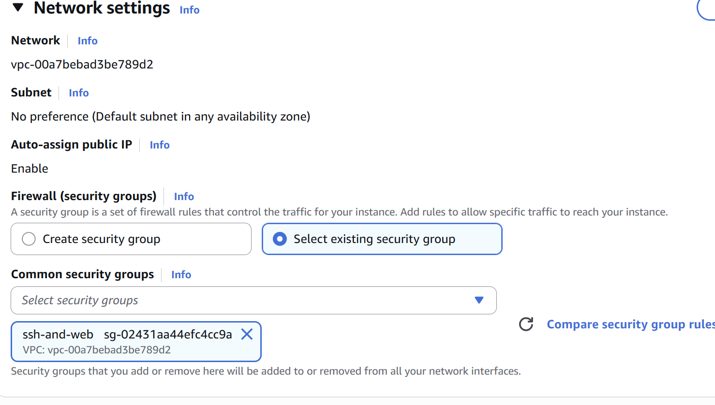

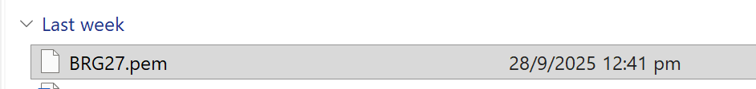

# **File Transfer & Permissions**

* - Use `wget` to download remote files to your VM.
* - Use `sudo cp` to move them into the web directory.
* - Use `scp -i key.pem localfile ubuntu@IP:/home/ubuntu/` to copy files from local to VM.
* - Use `chmod` or change ownership if facing file access issues.

# **Budget and Cost Monitoring in AWS**

* - Log into AWS Billing Dashboard via EC2 console.
* - Set up a budget alert to avoid unexpected charges.
* - Review instance charges and terminate unused resources.
* - Avoid launching high-tier or GPU-backed instances.

From the AWS console, I can go to Billing and Cost Management Home to set up a budget alert to alert when the charges have reached the limit set. Apart from setting up the budget alert, I can also see how much cost and usage from AWS console itself.

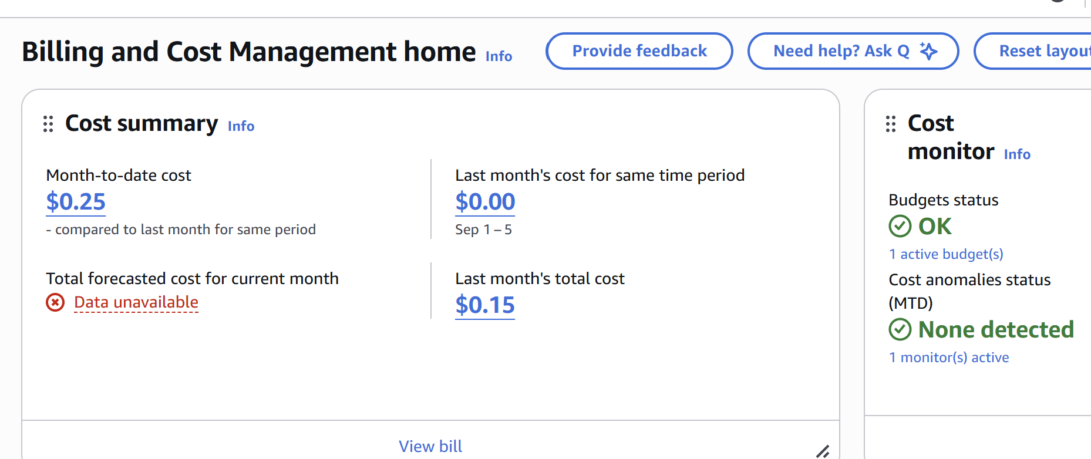

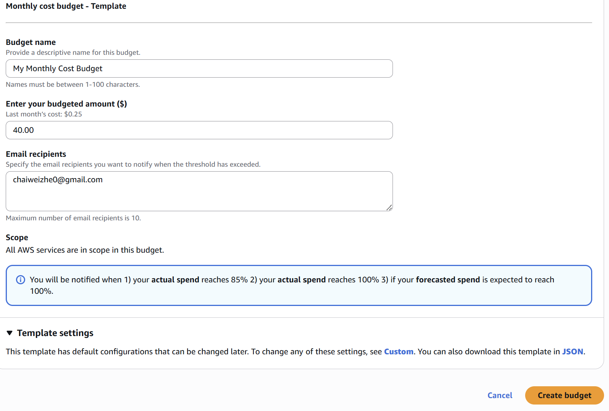

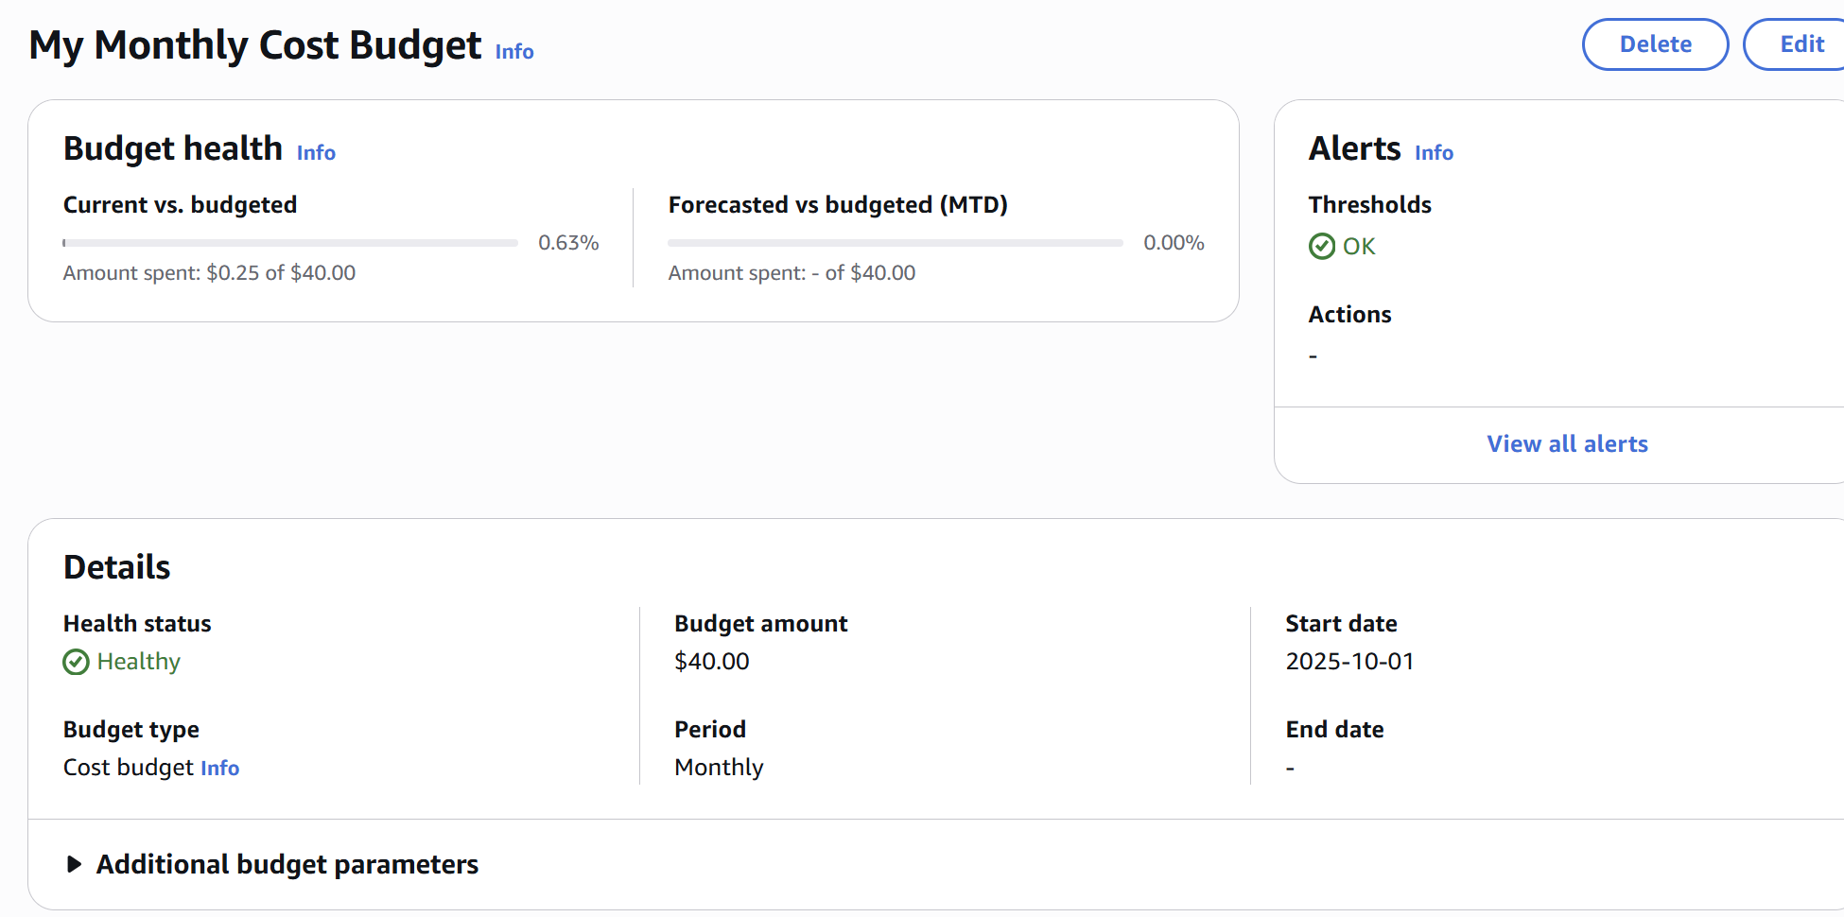

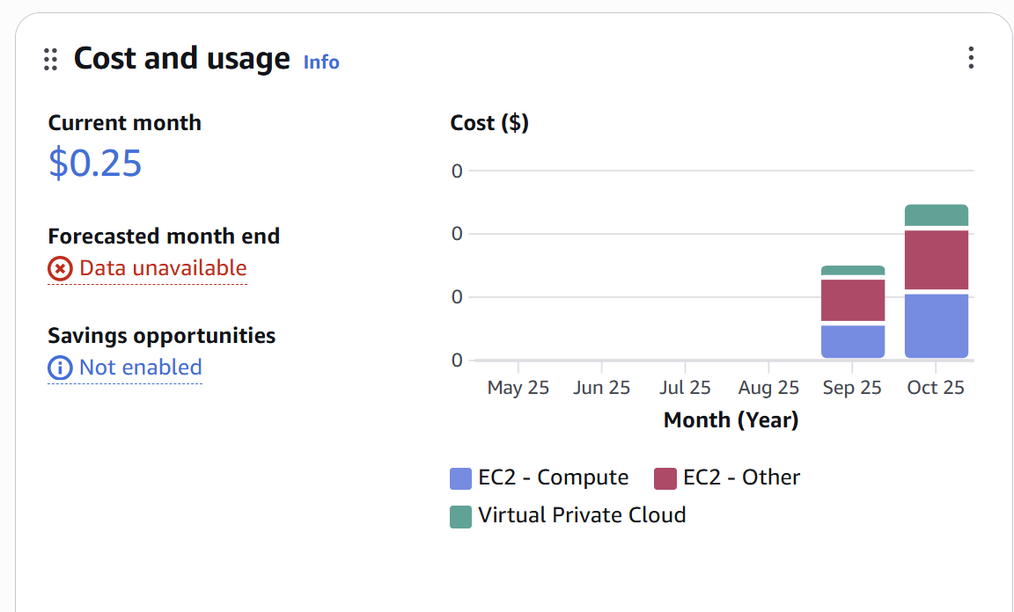

Lab 2b-2: Introduction to Bash Scripting & System Automation:

# **Part 1: Navigating the File System and Managing Files**

* Students will:
* - Create and navigate directories
* - Use file commands to create, copy, rename, and delete files

# **Part 2: Creating and Executing Basic Bash Scripts**

* Example: `hello_world.sh`
* - Add `#!/bin/bash`
* - Use `echo` to display messages
* - Use `chmod 777` to make the script executable
* - Execute with `./hello_world.sh`

I start by creating a script with `touch hello_world.sh`, then use `nano hello_world.sh` to update the script starting with `#!/bin/bash`, then with `echo “Hello, World!” `. Afterwards, change the permission of the script to make it executable for all the users so I can execute the script with `./hello_world.sh`.

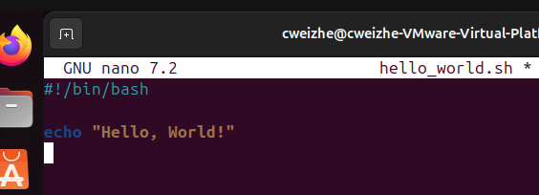

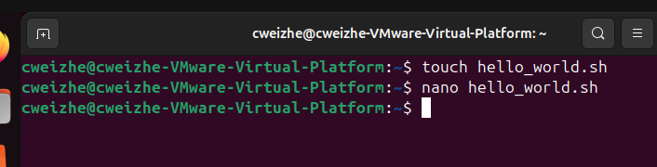

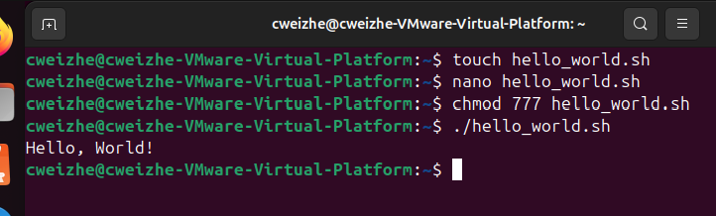

# **Part 3: Implementing Loops and Conditionals**

* Example: `system_info.sh`
* - Use `for` loop for countdowns or iteration
* - Use `if`, `elif`, `else` to evaluate user input
* - Use `read` for interactive input

First, I will use touch command to create the script, then use nano to edit it. I will then input the required script commands into the file, then save it. Then change the permission of the script so anyone can execute it.







For `if`, `elif`, `else` and `read` command, I will still use the same file to edit with nano, then add in the updated script. Now, the user will be prompt to input a number and according to the number input by the user, different text will be displayed based on user input.

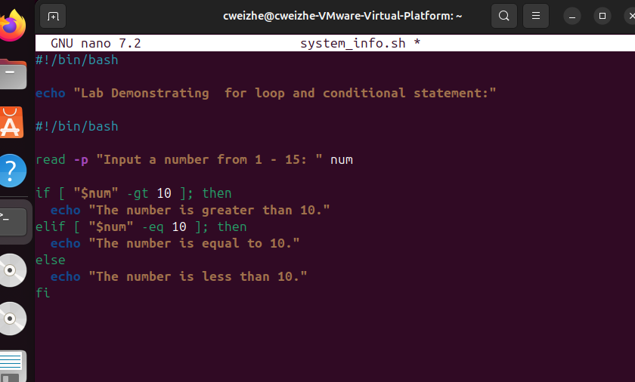

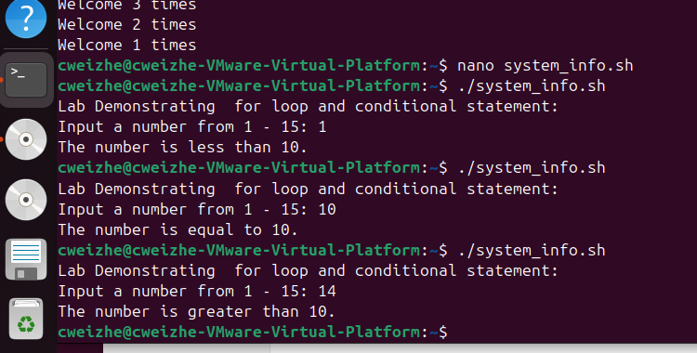

# **Part 4: Automating System Monitoring Tasks**

* Example: `resource_monitor.sh`
* - Use `top`, `free -h`, `df -h` to monitor system resources
* - Use `sleep` and iteration input to control monitoring frequency

Similar to the previous 2 exercises i start by creating the script with ` resource_monitor.sh`, then update codes that will help to retrieve CPU usage, Memory usage and Disk usage. Afterwards, I will set the permission to 777 then execute it. The log file created is saved at ‘/home/cweizhe’.

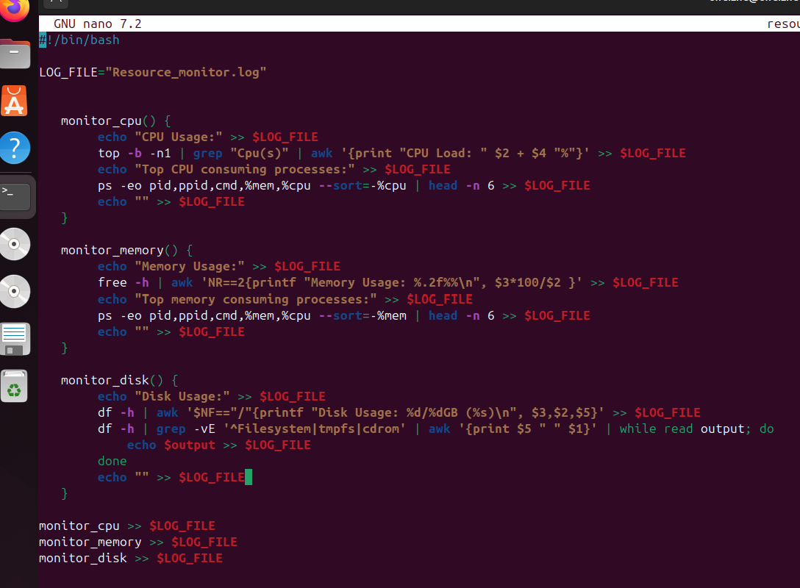

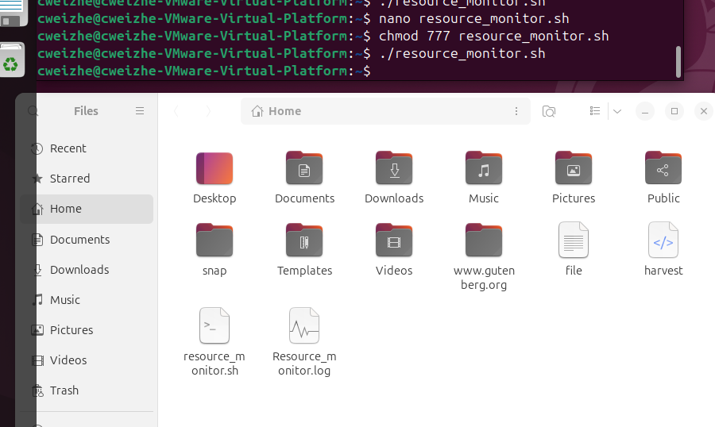

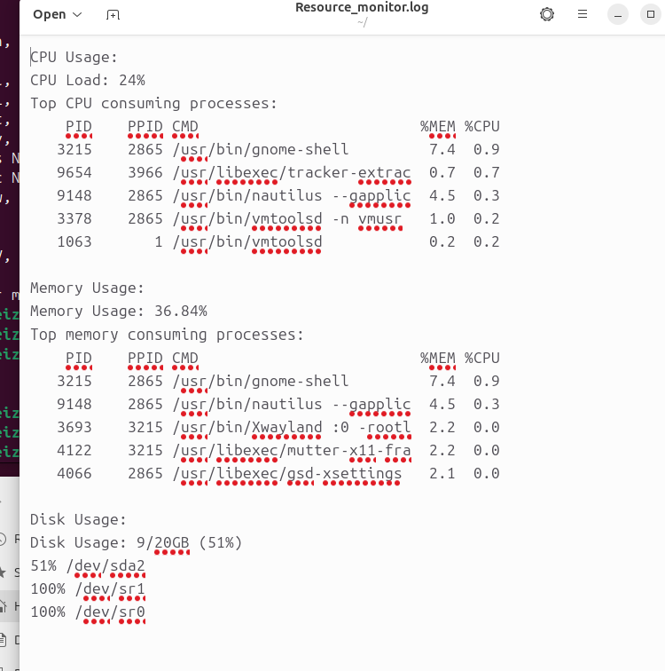

# **Reflection Questions**

* - What command did you use to create a new directory?
* - How can you view the contents of a file without opening it in a GUI?
* - What is the purpose of `chmod 777`?
* - What does `#!/bin/bash` do at the start of a script?
* - What happens when invalid input is entered into a script?
* - What output does `free -h` show?
* - How would you monitor network bandwidth in a Bash script?

I have used `mkdir` to create a new directory.

`cat` and `less` can be used to view the contents of a file.

`chmod 777` is used to ensure the file can be read, write and executed by every user.

The purpose of `#!/bin/bash` is to instruct the operating system on which interpreter should be used to execute the script.

When there is an invalid input entered into the script, the script might be terminated when it starts to run.

The command `free –h` will produce human readable output.

If I would monitor the network bandwidth in a Bash script, I include the command `netstat` in it.

### 5. DNS Setup and SSL Configuration

#### DNS Management

* Domain used and DNS record configuration.
* Tools used to verify DNS propagation.

#### SSL Certificate with Let’s Encrypt

* Certbot usage and challenges.
* HTTPS redirection and security headers.
* Reflection on the importance of encrypted traffic.

Before starting with domain creation, i have to ensure that the inbound ports for port 22, 80 and 443 has to be open, and Apache installed. Then I have created a domain name “cweizhe22334455.online” using GoDaddy. I will then set up my A record under the DNS Records using the public IPv4 address, `3.27.217.115`, that my instance is currently holding. The name will remain as ‘@’. Once the record has been added, it will take a while for DNS records to be in full effect across all servers on the internet.

Afterwards, I used the website `<https://www.whatsmydns.net/>`to check that the DNS record has been recorded in other cities. Once it has been recorded, a tick will be shown. Once the IP address of DNS has been recorded, it can now receive be ping from the VM or EC2 instances.

However, I realised that each time when the instances are on and off, the public IPv4 address of the instance will change. My original IPv4 address changed from `3.107.8.103`to `3.27.217.115`. This means that if I have not applied any service, like a Certbot, that links to the original IP address of the instance, I will have to reconfigure A record on the DNS to match the current public IPv4 address. Afterwards, the DNS IP address will be fixed to the domain name. When the IP of instance has refreshed again, there will be a digital certificate linked to the domain name beside the URL.

Certbot is a software tool that helps to generate or renew a trusted TLS certificate from the Let's Encrypt certificate authority to enable HTTPS on the selected domain. Similarly, myMurdoch Learning website has a digital certificate issued by the company DigiCert. When using Certbot to generate a certificate for the domain, there is a chance that port 80 and port 443 has been forgotten to be open for connections, causing the Certbot failing to generate the certificate.

Lab 3a-1 Domain, DNS and TLS Certificates with Let's Encrypt

# **Lab Setup and Tasks**

* - Launch Ubuntu VM using Amazon EC2, Azure, or DigitalOcean.
* - Ensure inbound ports 22 (SSH), 80 (HTTP), and 443 (HTTPS) are open.
* - Install Apache: `sudo apt install apache2`.
* - Record public IP address of the VM. Access in browser to confirm Apache page.
* - Register a domain (Namecheap, GoDaddy, Cloudflare, Route 53, etc).
* - Create an A record pointing your domain to the public IP of your server.
* - Wait for DNS propagation and test with browser, ping, and nslookup.
* - Install Certbot: `sudo apt install certbot python3-certbot-apache`.
* - Run: `sudo certbot --apache` to generate and install the certificate.
* - Check site: HTTPS lock icon should appear in browser.

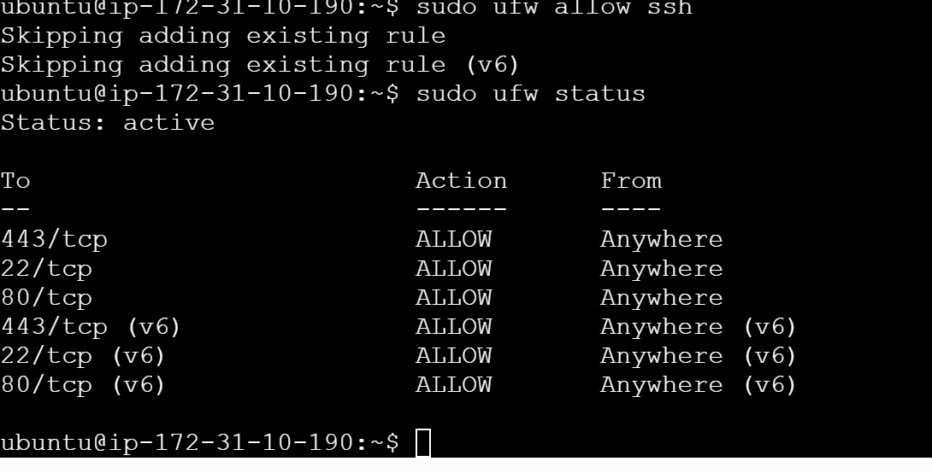

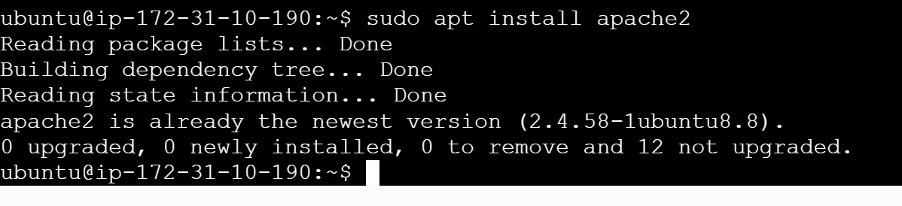

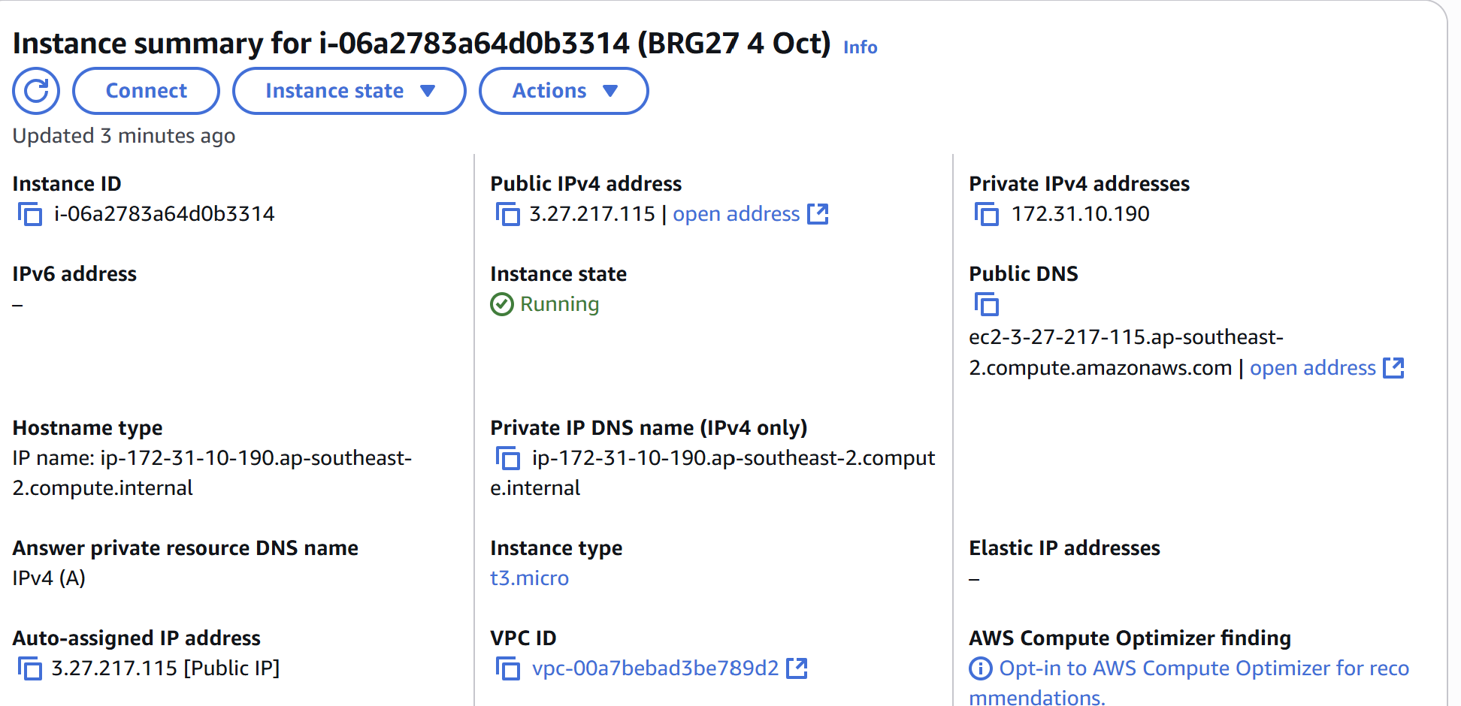

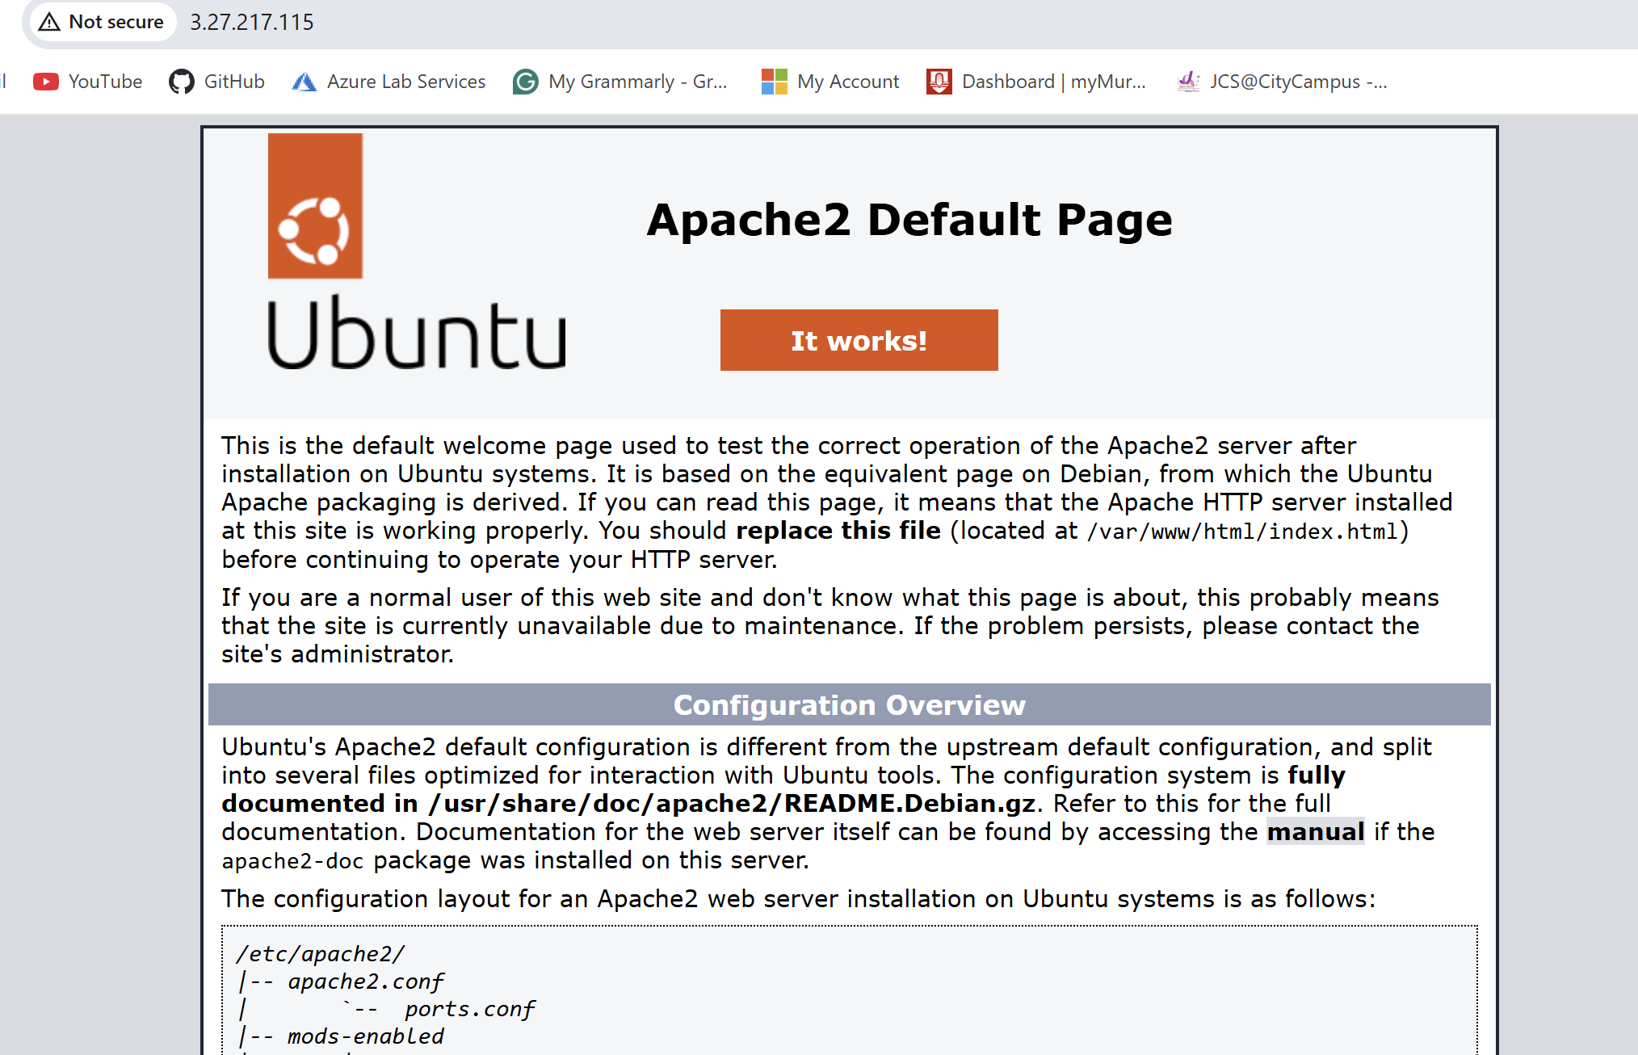

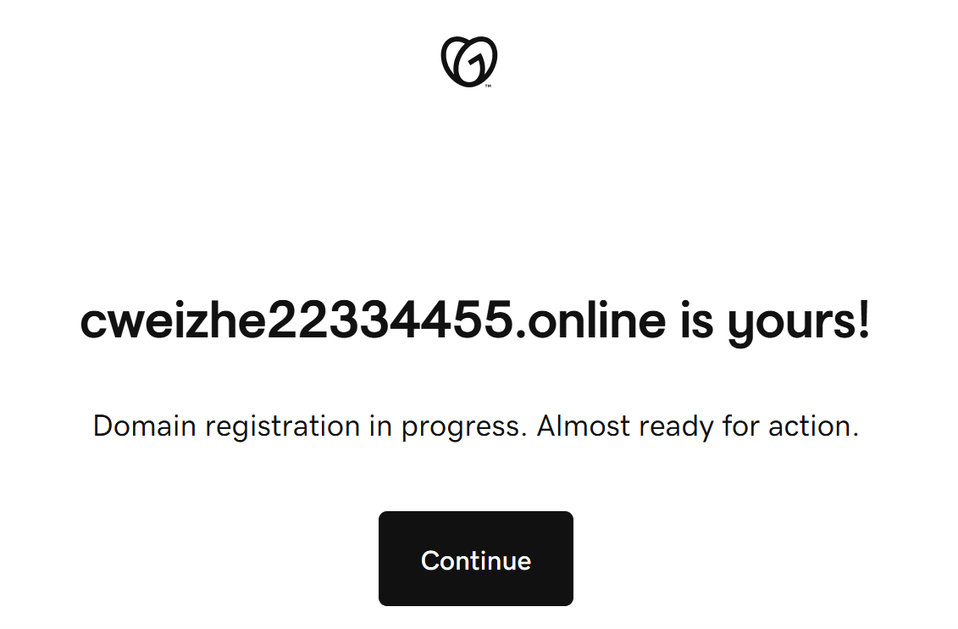

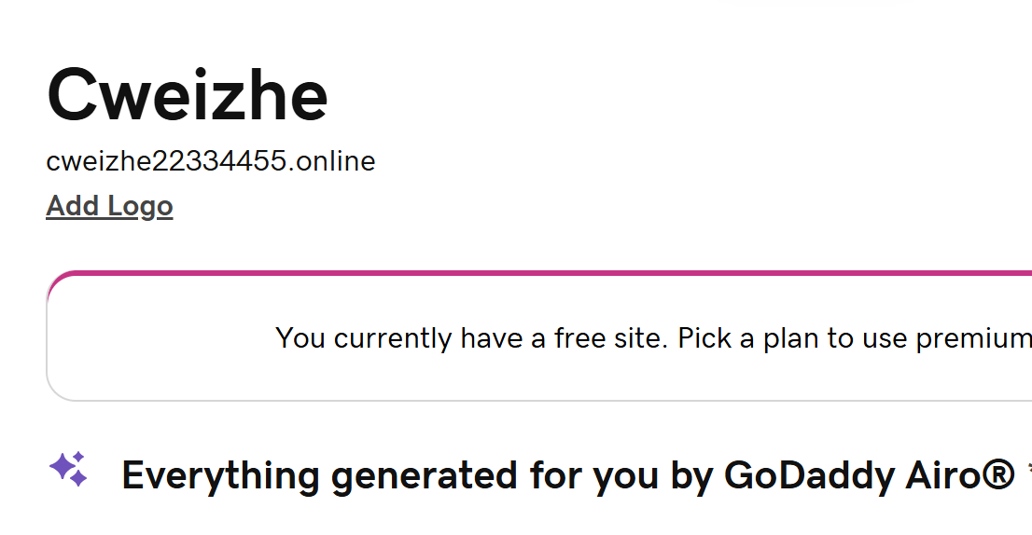

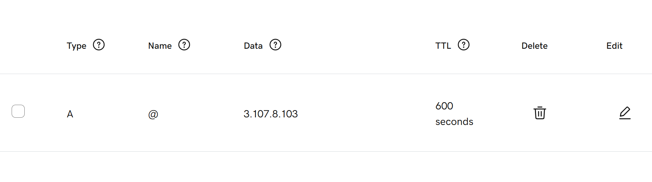

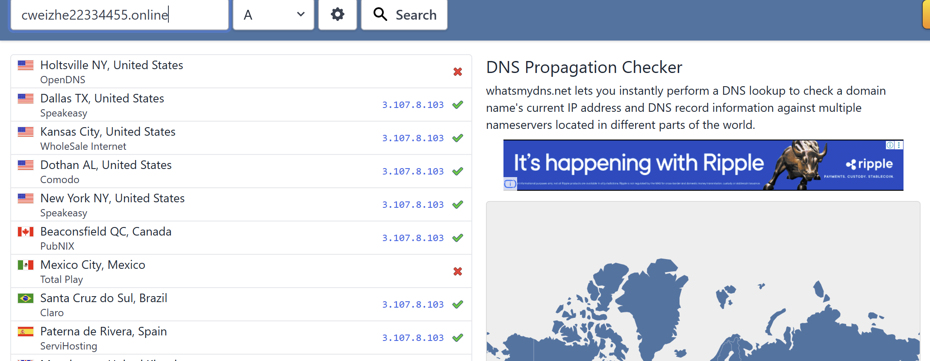

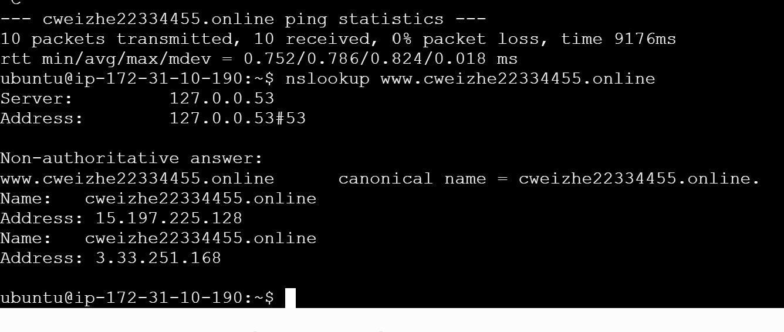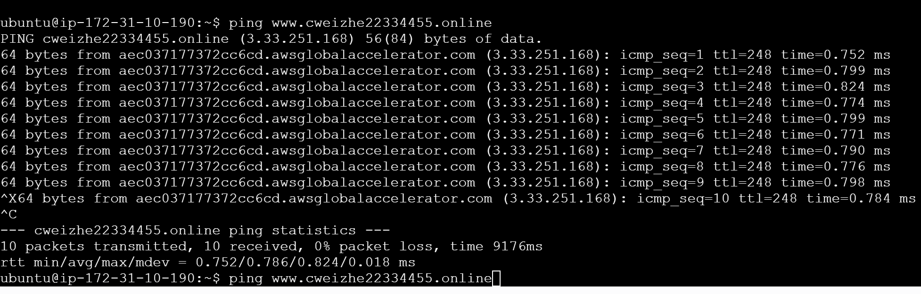

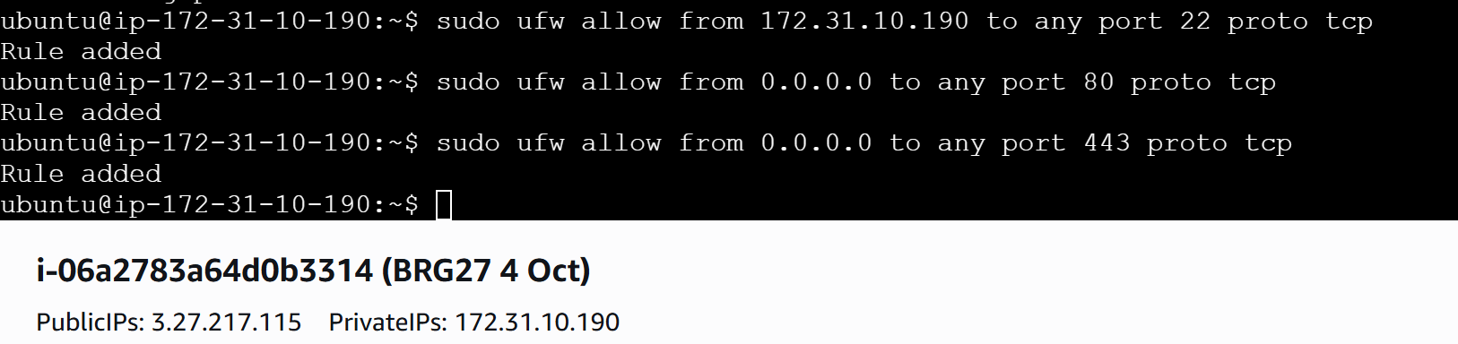

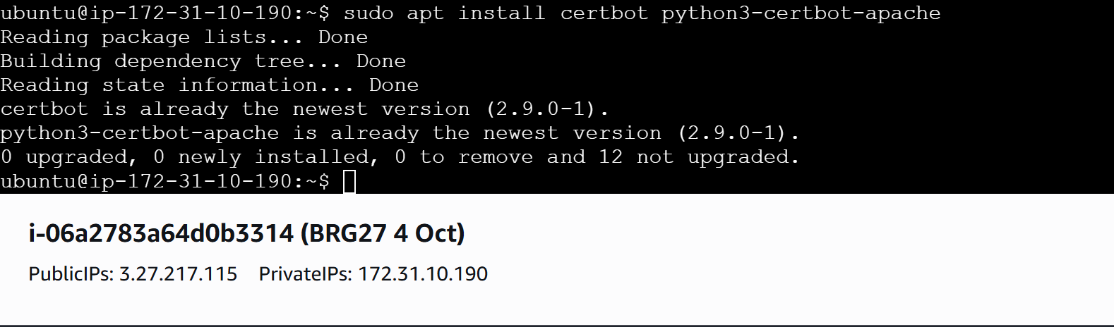

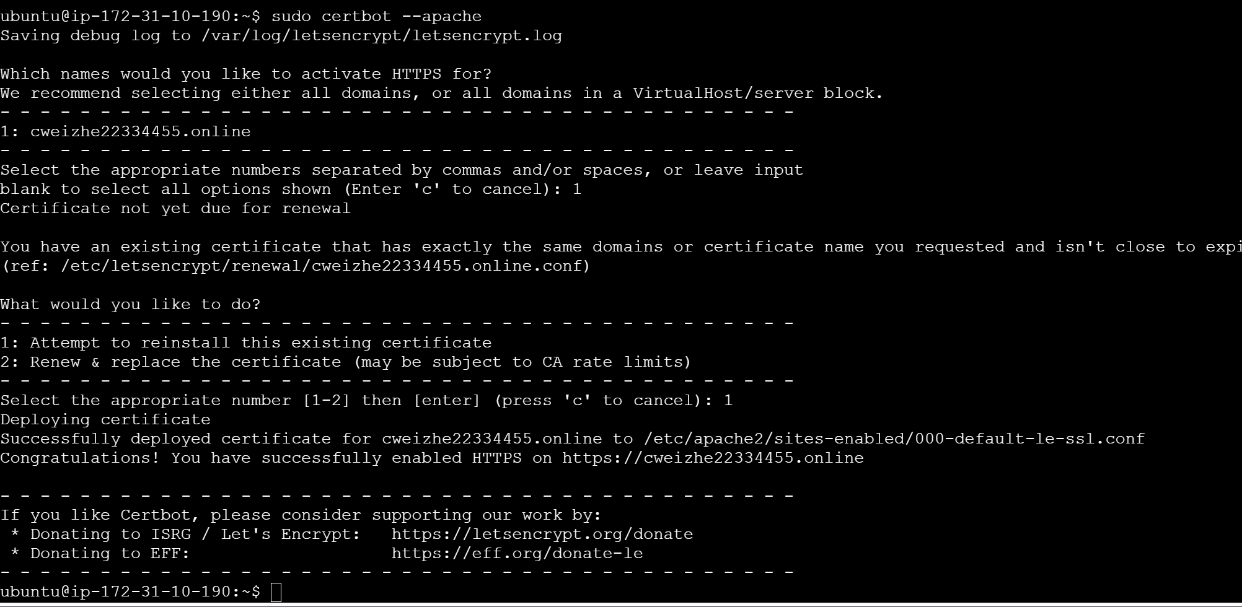

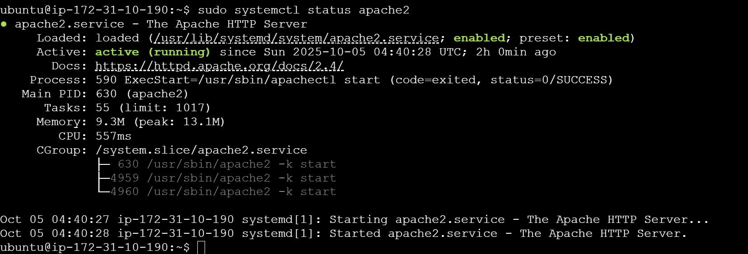

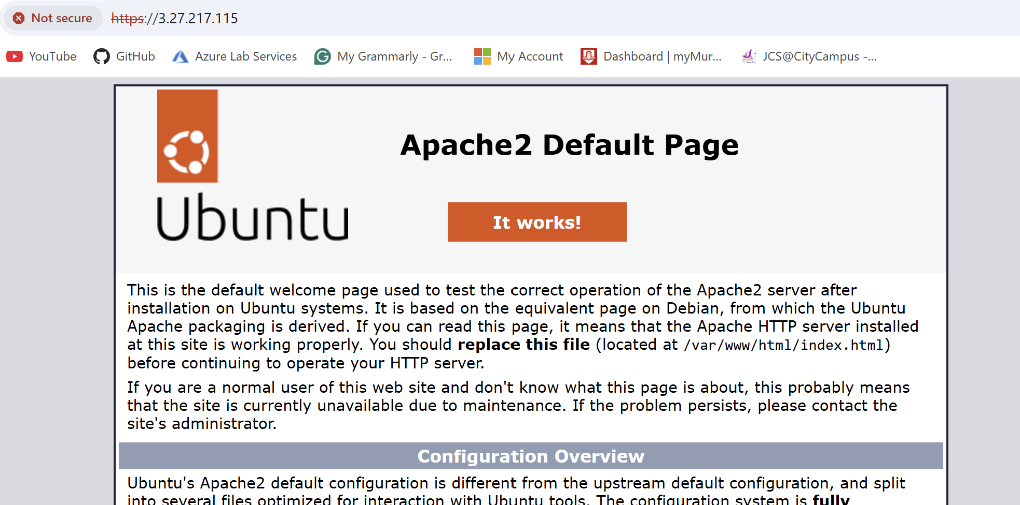

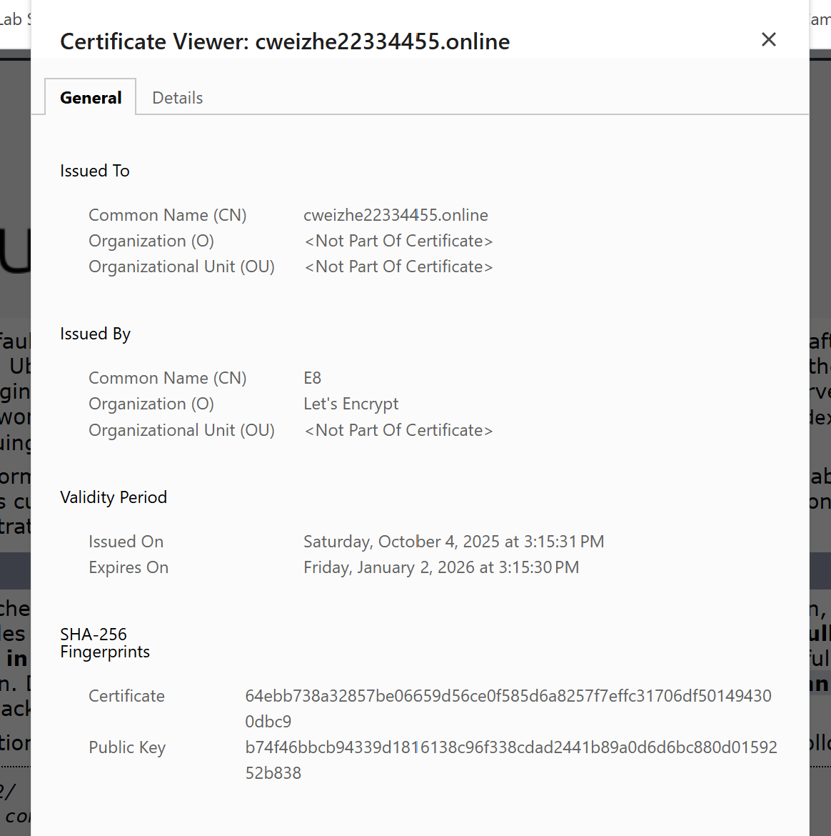

The following snapshot is a digital certificate issued by DigiCert to the website, `https://moodleprod.murdoch.edu.au/my/ `.

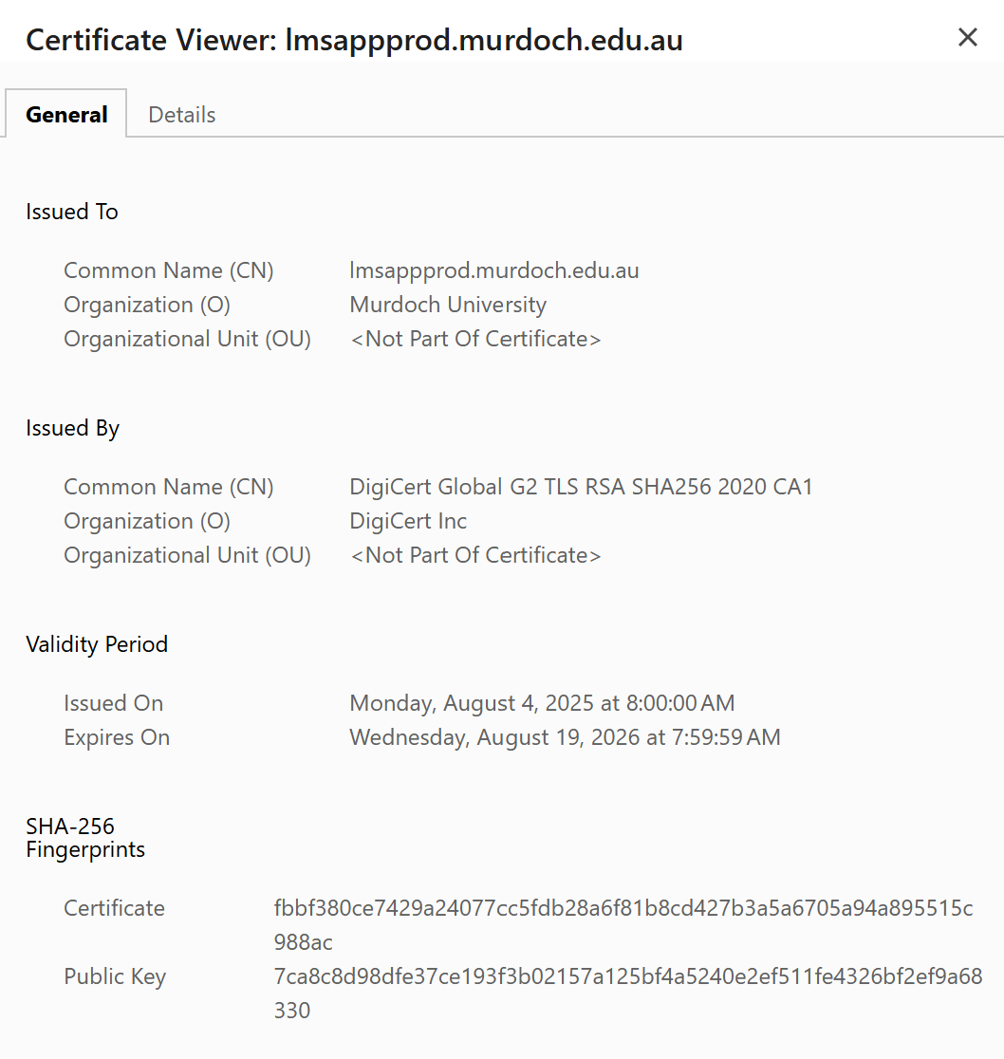

### 6. Automation and Cron Jobs

* Describe cron jobs configured.
* Script improvements and error handling.
* Importance of automation in real-world environments.

A cron job is a scheduled task that runs a command or script at a specific time.

Automation allows lesser human to complete jobs that are repetitive so human resource can be put into use at other areas that requires more assistance.

Automation is important as it can help to handle repetitive tasks and not require human interface too frequently.

### 7. Consulting Simulation and Additional Server Service

#### Peer Consultation Reflection

* Overview of your proposed solution (stack, budget, security).
* Feedback received and how you incorporated it.

#### Optional Lab (Your Chosen Service)

* Service deployed (e.g., MariaDB, vsftpd, Docker).
* Configuration steps and security considerations.
* Reflection on learning a new service independently.

For the additional server service, I have decided to do the research on the htop. It is a useful command-line tool that allows users to determine the cause of load by each process, like what Task Manager can do for Windows. Only root has the permission to see all the system processes, other users can only see their own system process. It can be used to kill processes, which means that it can terminate a program or a task that is running in Linux.

The steps for configuration are simple; it can be installed on Ubuntu like how Apache2 was installed.

First, we start with the command `sudo apt update`, to update the system. Followed by `sudo apt upgrade`, to install the newest version from the internet.

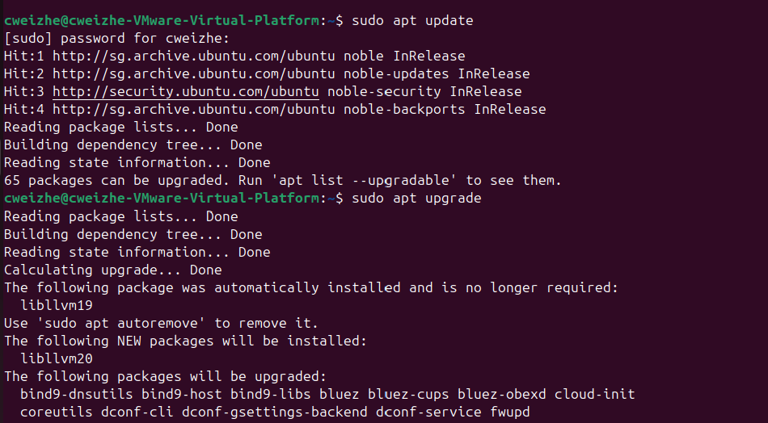

Next, we install htop using the command `sudo apt install htop`:

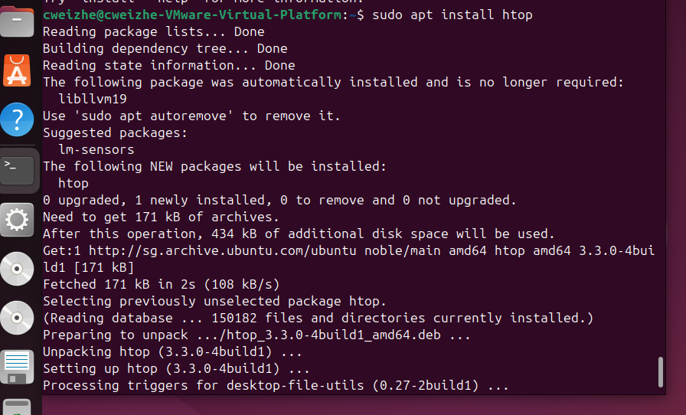

To run htop, we just need to type `htop` in the terminal and press enter:



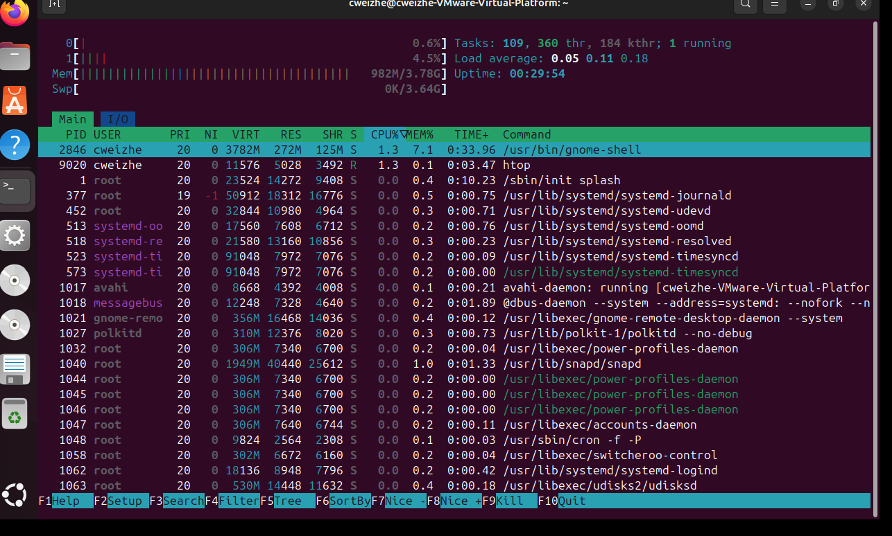

### 8. Problems Encountered and Solutions

(Create a table or list format.) | Problem | How You Solved It | |——–|——————-| | Example: SSL failure | Opened firewall and EC2 SG ports |

Failed to connect public address to domain as the public ipv4 will change when start instances again. | Solution

### 9. Industry Relevance

* Which career roles this lab series relates to (SysAdmin, DevOps, etc.).
* How this experience helped build confidence in real-world skills.
* Mention any frameworks referenced (NIST, OWASP, SANS).

These lab series are related to career roles like System Administrator, DevOps Engineer, Linux Engineer as these types of career roles that require a strong foundation on Linux operating system.

This experience helps me to have a better understanding of how Linux is important in as a real-world skill as many careers are related to it especially in the IT field.

### 10. Final Reflection

* Summarize your overall learning experience.
* What skills you improved.
* How you would approach future server projects differently.

Overall, the lessons of this course are scheduled fast, 2 weekends in a row and there are only 4 days of lessons. It will be tough to understand that much knowledge and going through the lab activities in this period of time. I would need more time to learn and train on using the Linux commands on Ubuntu to be more familiar with it.

During these 4 lessons, I have learnt how to use the Linux commands, permission, scripting, understand how to implement TCO to decide on the items needed to be bought, understand the how to use Amazon EC2.

In future if I were to approach server projects, i will need to be careful on each step to configure. Mistakes like typo error can cause the entire configuration to fail more easily. It will be hard to trace back to see what the problem is, and more time will be wasted on reconfiguring.

### 11. AI Tools Used (if any)

* List any AI tools (ChatGPT, Copilot) used for grammar, scripting help, etc.
* Be honest and specific.

### 12. Appendix (Add as needed)

* Bash scripts
* Cron entries
* Screenshots
* NGINX or service config files
* GitHub repo file structure